

MARKET MAKER MODELS

**TIME FRAME ALIGNMENT**



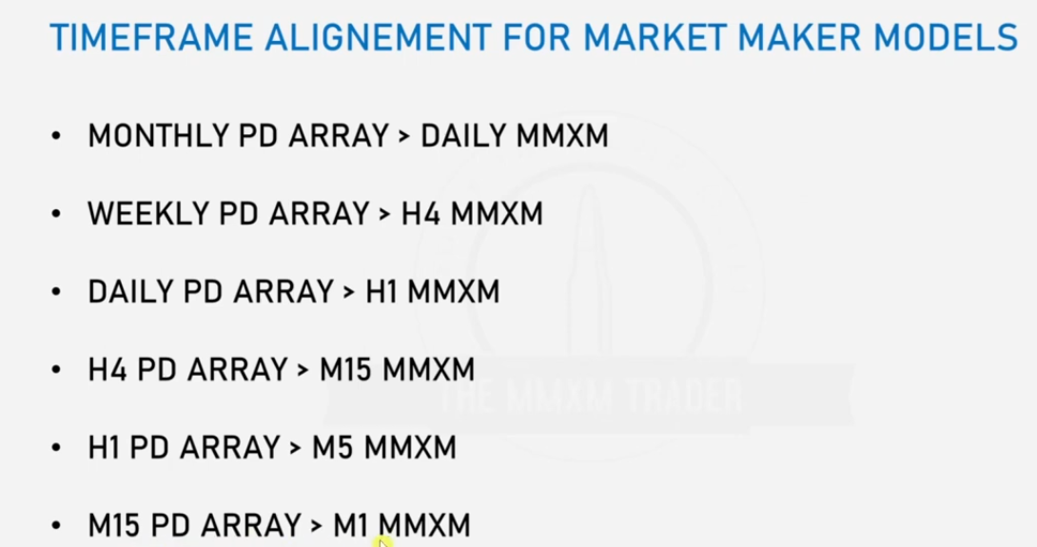

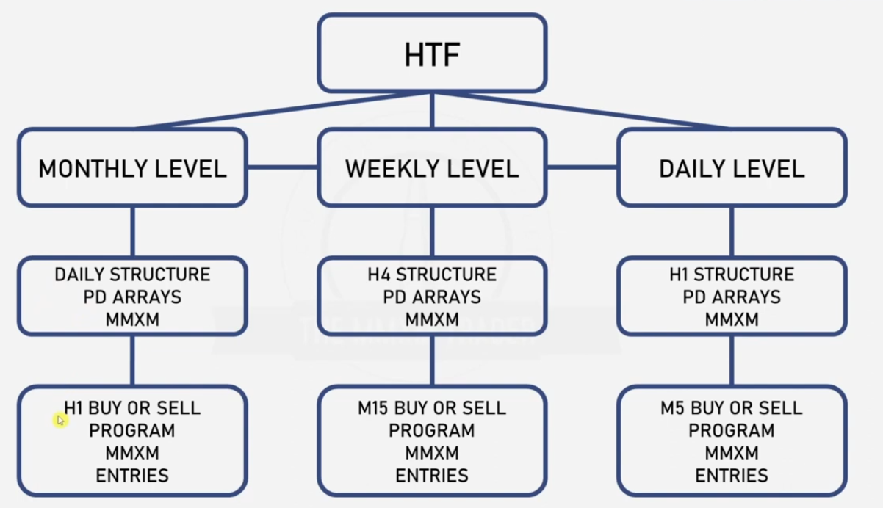

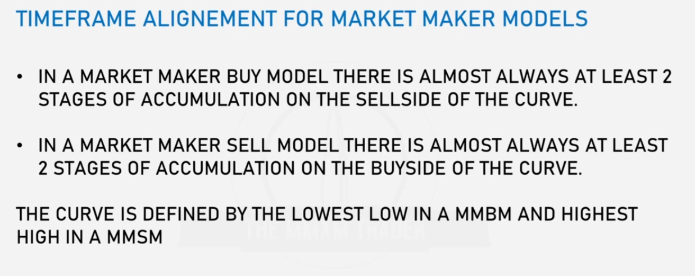

MMBM

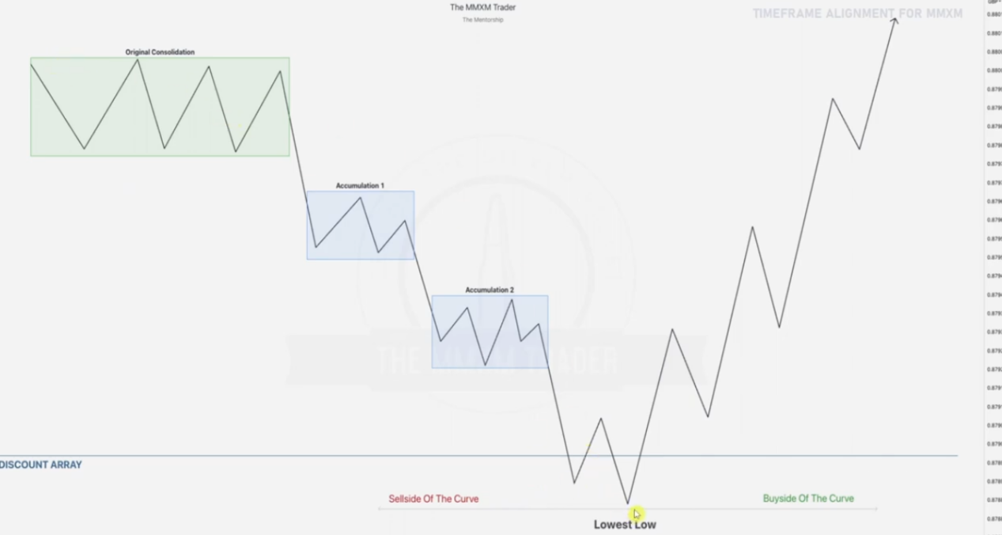

Lowest point before moving from sell side to the buy side of the curve must hit a key level eg a discount pd array in our case.

MMSM

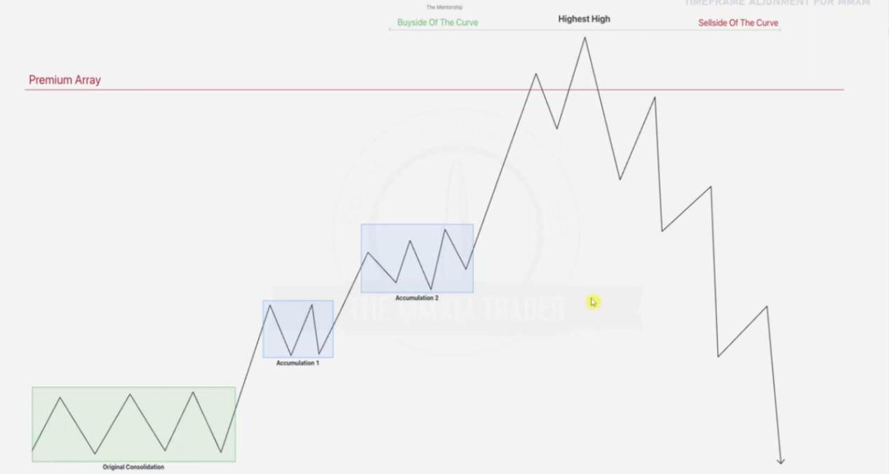

Highest point before moving from buy side to the sell side of the curve must hit a key level eg a premium pd array in our case.

EXAMPLE ONE

Given a monthly chart

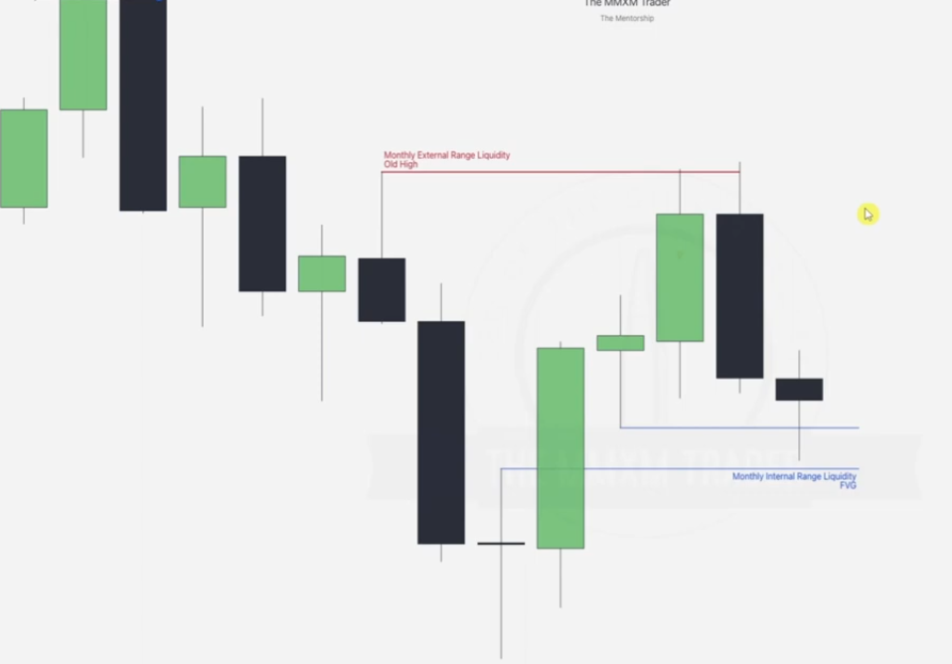

This one has been labelled basically using the IRL Vs ERL concepts

Going to daily-- check the mmxm time alignments again(pd array to mmxm)

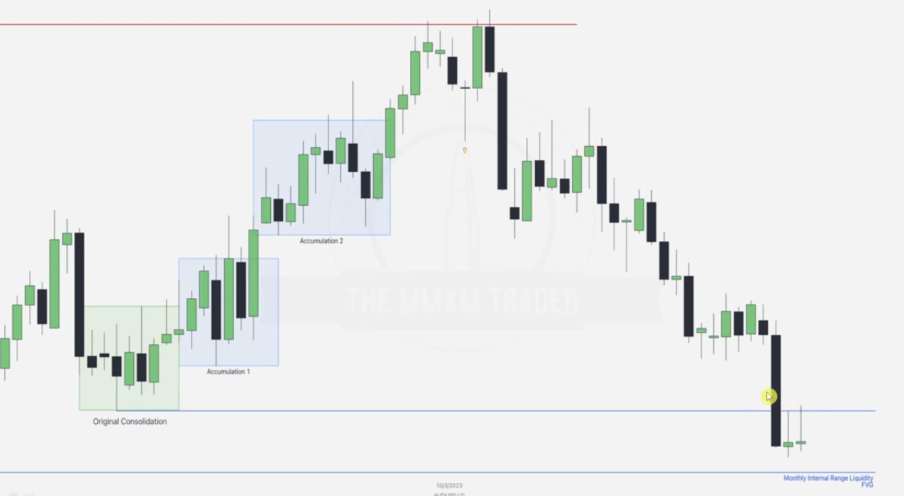

The accumulations are as labelled, price goes up and takes out the buy stops from where we notice order pairing, we then wait for a break in structure, which happens and we notice a fall in price aiming for the monthly FVG labelled before -- but remeber we can still do multiple entriy strategies within that same range.

EXAMPLE TWO

Given a weekly chart

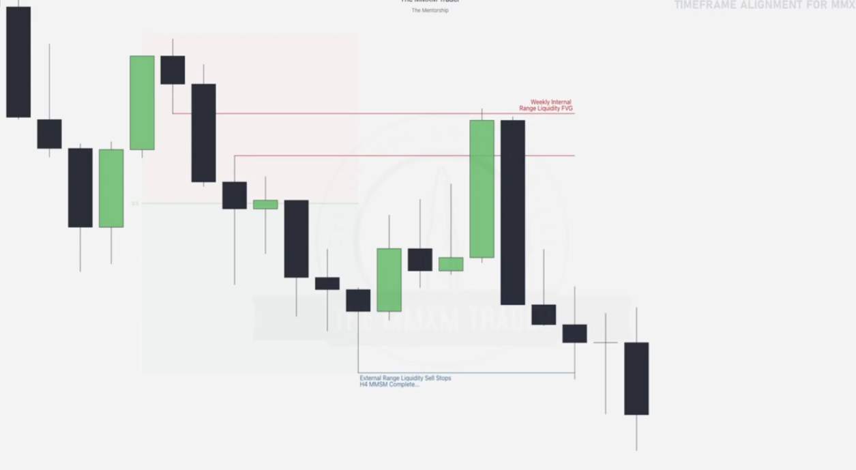

We do the ERL vs IRL

NOTE THE MMSM using the blue, which note the beginning of the consolidation and an ERL

Then go to 4hr chart

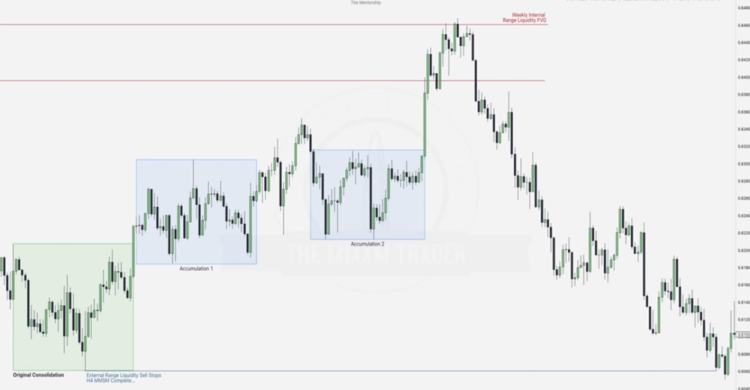

Note the accumulations, lowest of the first accumulation marks the sell stops (major one), then using the ERL vs IRL theory we denote most of the movement. Also take note that in order to form some of the ERLs, failure swings on the buy side are aimed at from the sell side. Another note is that the sell side has some FVGS IRLS being respected and at the same time we see high resistance liquidities being formed on it which we can aim at.

EXAMPLE THREE

Given the daily chart

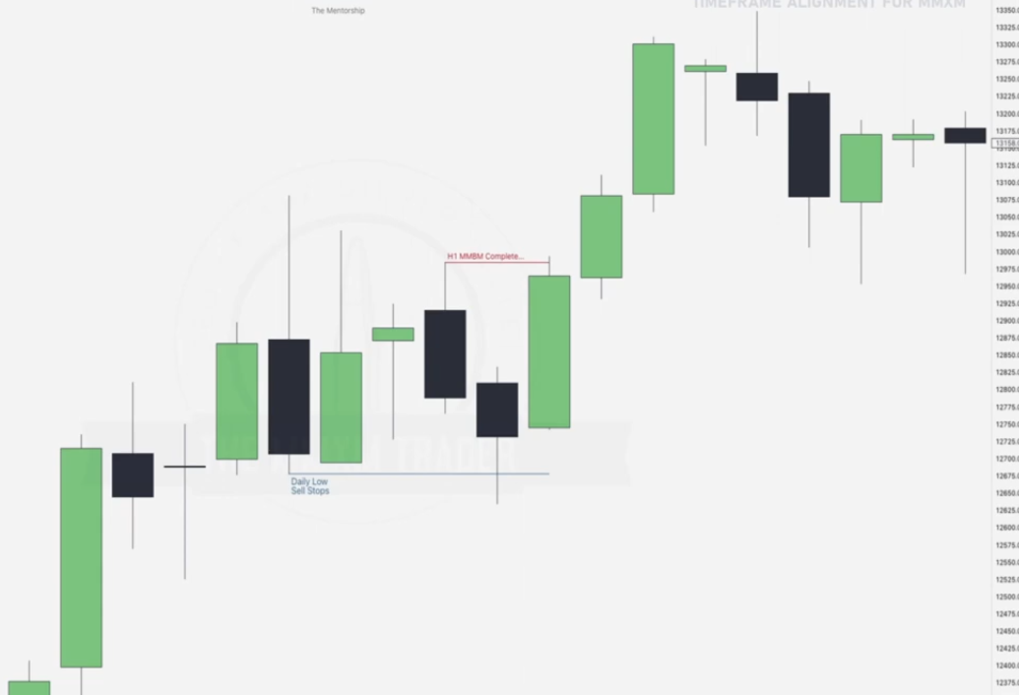

Going to hourly chart

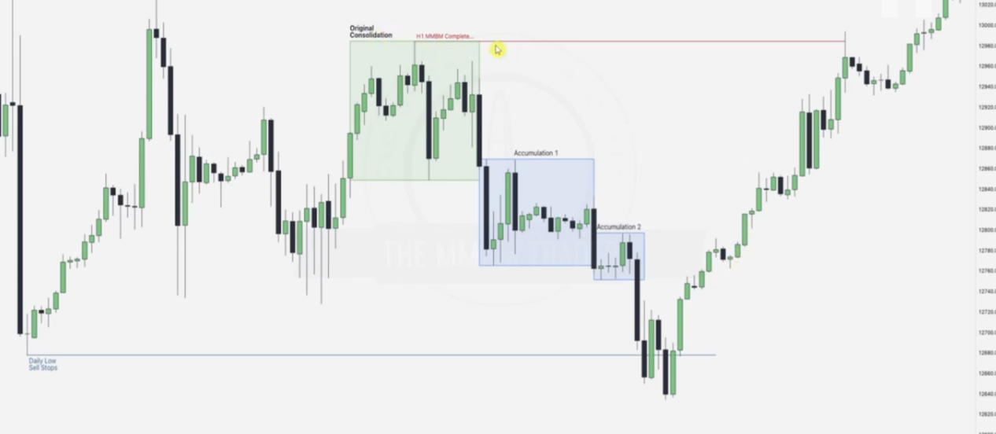

Original consolidation forms the buy stops, at the daily sell stops we monitor order pairing, wait for a confirmation in terms of break of structure, bearish FVG on the side is broken and this confirms the new buyside.

EXAMPLE 4

Going to 4hr chart

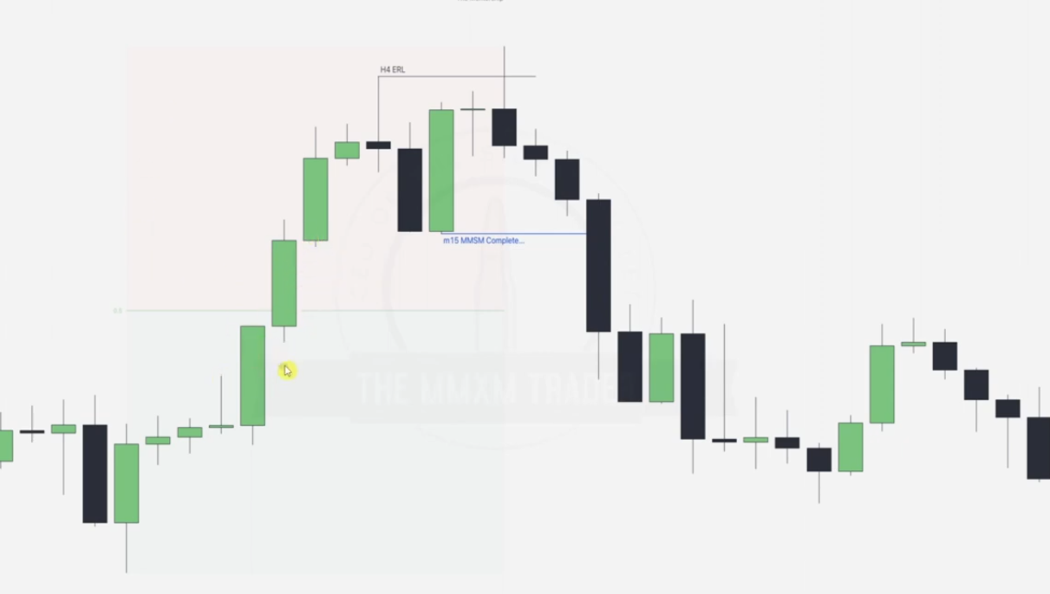

Draw the takes on liquidity, note that using ERL Vs IRL After taking the H4 ERL next target will be the highlightedFVG bcoz the first FVG was in premium.

NOTE THE MMSM using the blue, which also denotes the low beginning consolidation.

Going to 15 minute time frame

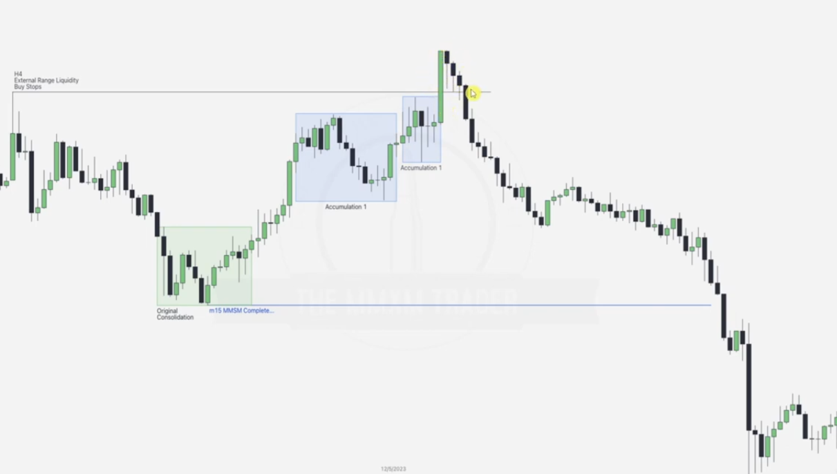

EXAMPLE

Going to the 1 hr chart -- scalper teritory

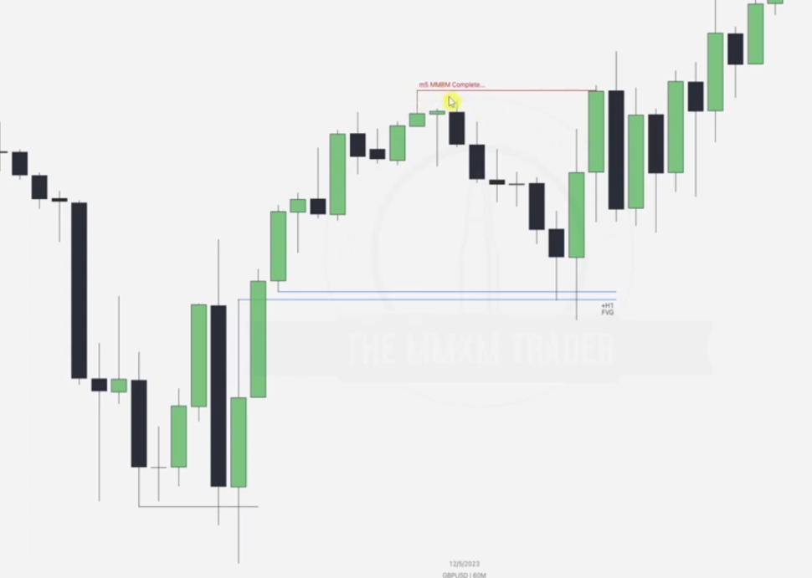

Draw FVGS ERLS Etc. PLUS THE MMBM which is in red giving you an ERL too with its first consolidation.

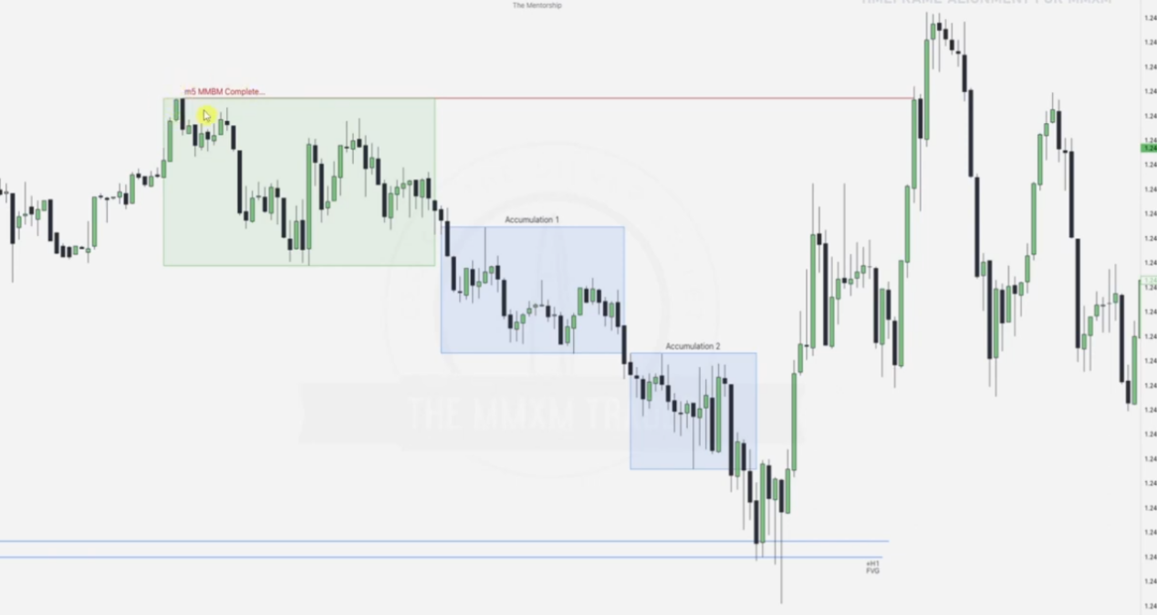

In the 5 minute chart, we note that in the first consolidation we can apply concepts of erl irl, failure swings, etc, then at point when the hourly FVG is hit we notice order pairing.

EXAMPLE

Given 5 minute

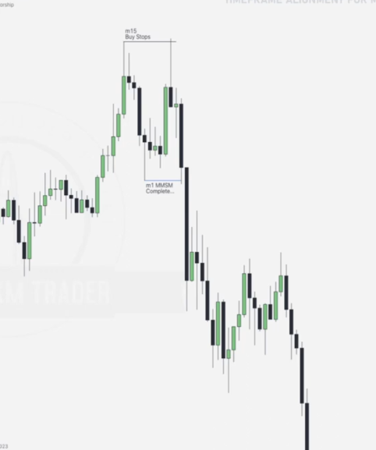

Best to use EURJPY sine they move faster. NOT RECOMMENDED

1 minute time frame

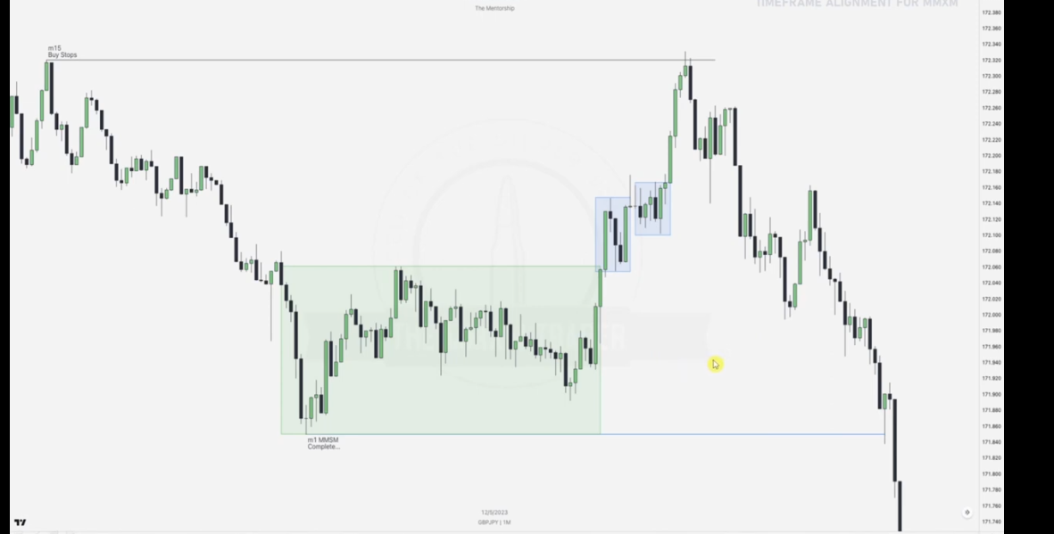

**MITIGATION BLOCKS**

**HOW TO TRADE MARKET MAKER MODELS**

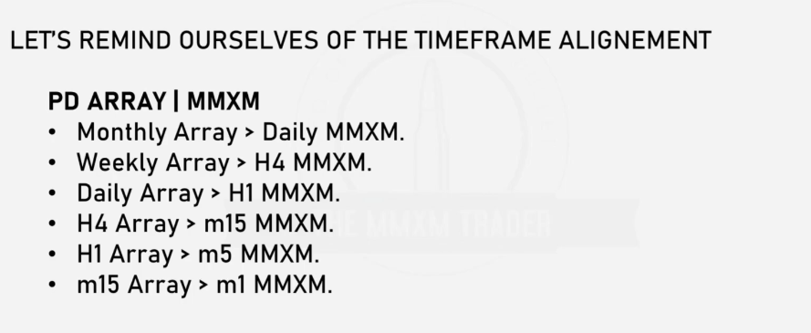

Given

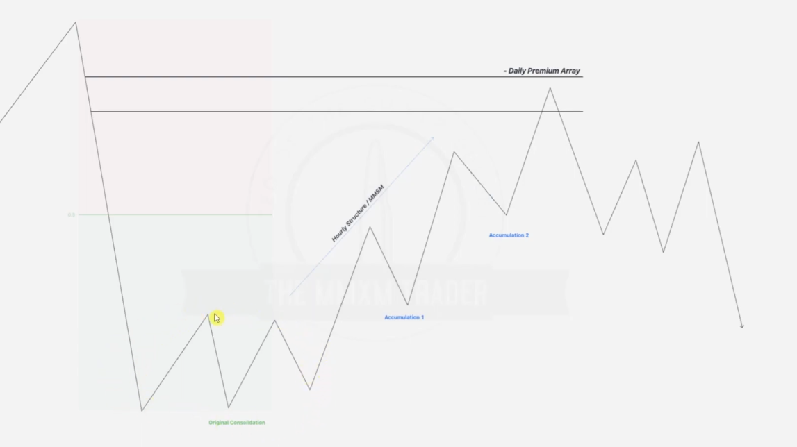

Draw a prem_disc

Look for the original consolidation

Note the accumulation phases(order pairing) 1 and 2 till we hit the daily premium discount array.

After hitting the prem array, we wait for a 1 hr stop hunt, from there we can wait for an opportunity to a market maker sell model in the 5 min structure--- as in the time frame alignment.

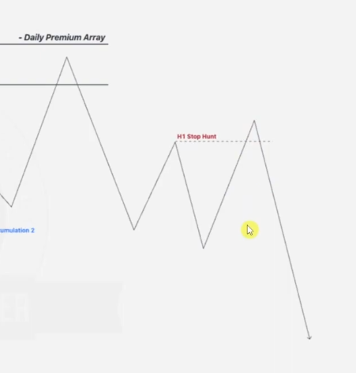

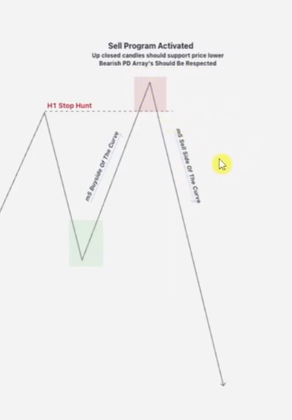

Sell program is activated by a premium array e.g up closed candle, BPR etc that supports price lower, bearish pd arrays should be respected

**EXAMPLE ONE:**

Given a daily chart

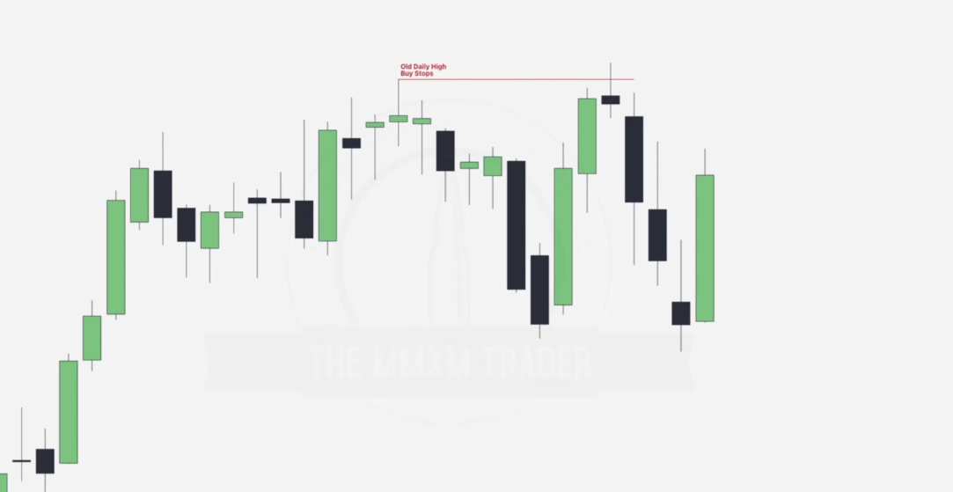

We expect to go from daily to 1 hr chart where we will note our 5 min market maker model. Draw the daily stop hunts first.

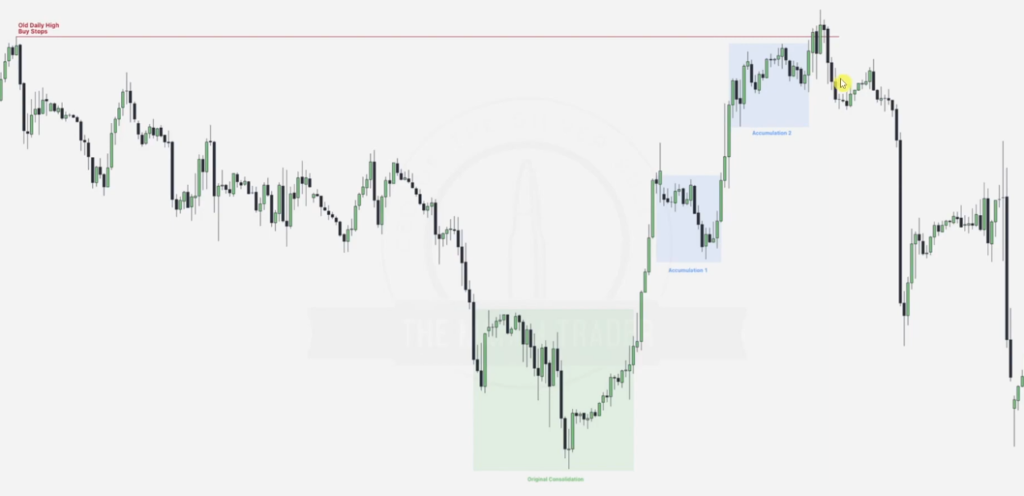

Note the first consolidation, then accumulations from 1 and 2

Note that after the old stop has been taken out now, from this point now we look for a PD array that will provide resistance to price going higher

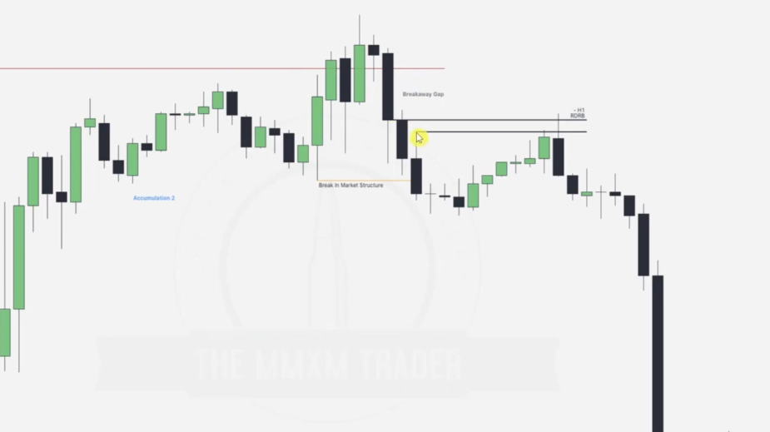

Note that this is seen as a 1 hr BPR forcing price to move downwards-- resistance , now where does our 5 min mmxm model fall

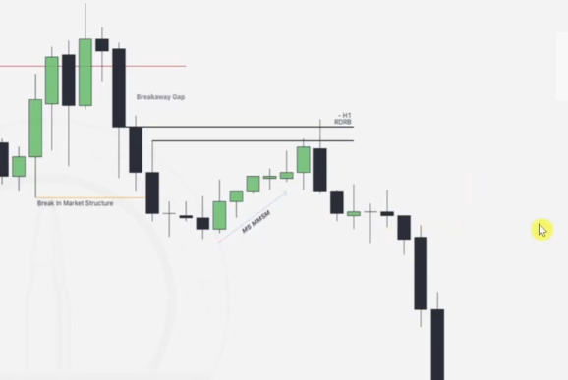

Going to detail 5 min, we have noted a 5 min market maker sell model though. NOTE THAT WE TOOK THIS BCOZ IT TOUCHES A PD ARRAY AT THE TOP WHERE WE WILL SEE ORDER PAIRING

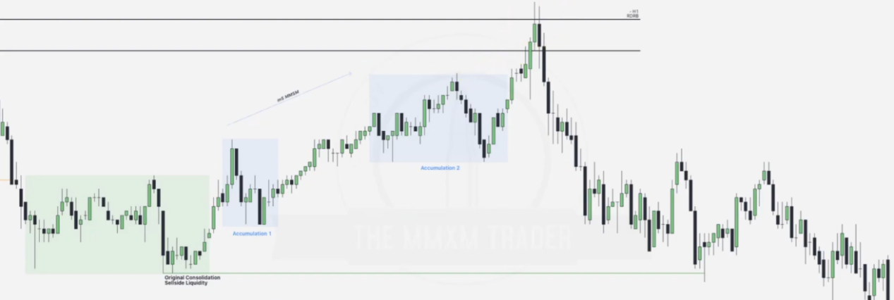

Original consolidation is a very good place to form the low of the model, we then note that accumulations 1 and 2 and after the tap into the Hourly BPR array, we get a high resistance PD array that will support the new sell by resistance

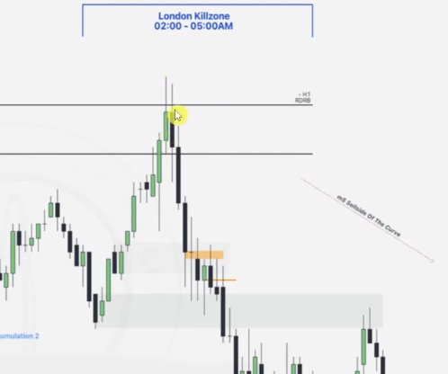

We note that there is an up close candle here

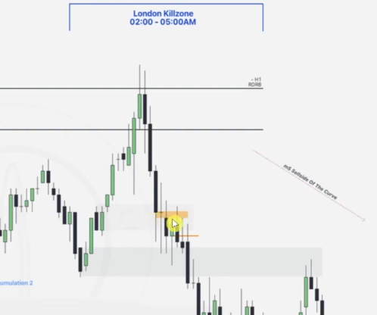

For thie, refer to mitigation blocks before coming back here where the cursor is

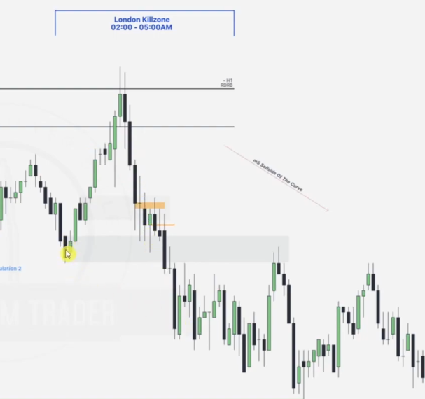

This OB has now become a breaker block

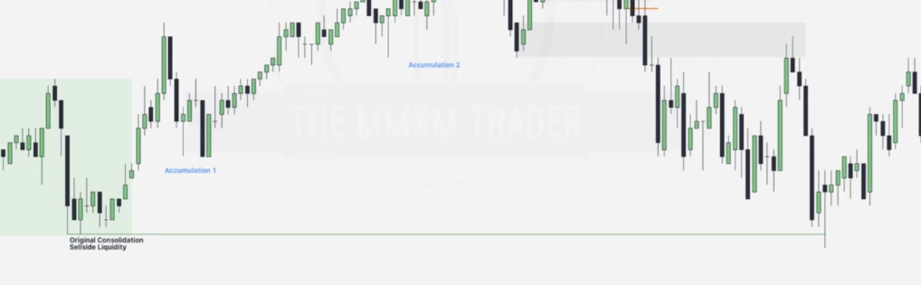

After tapping back into the OB, price now looks to take out the original consolidation sell side which was created by EQUAL LOWS

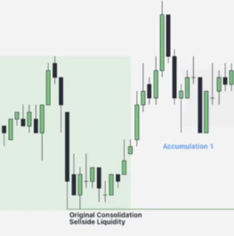

EXAMPLE 2

Given a weekly chart

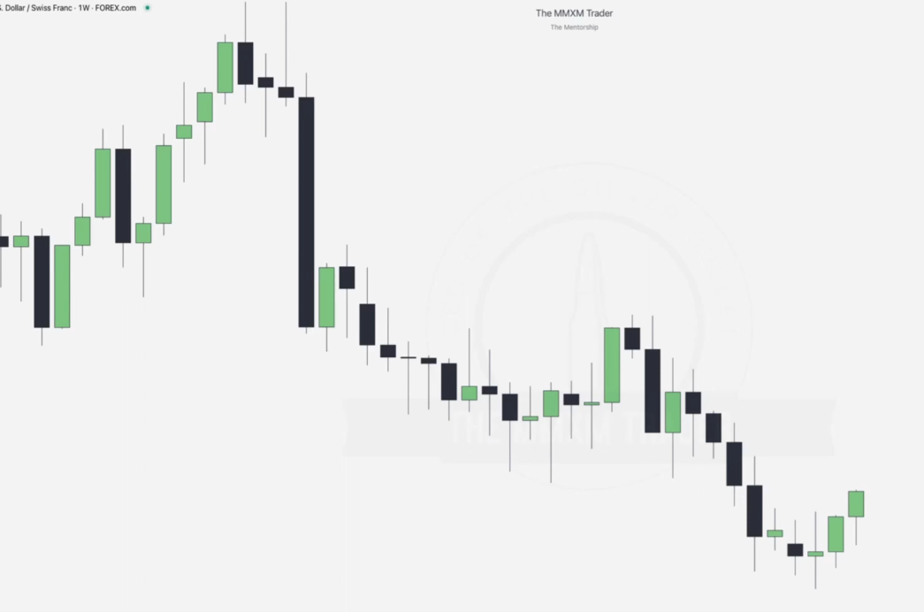

Since this is a weekly chart, we cannot go backwards too far, hence we draw a nearby ERL taken out(order pairing)

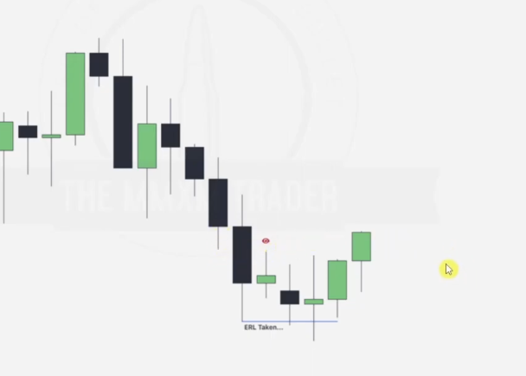

Next step is now noting an ERL or PD array which will form our stop hunt, we notice an FVG as below, hence our next draw on liquidity will be from ERL to IRL

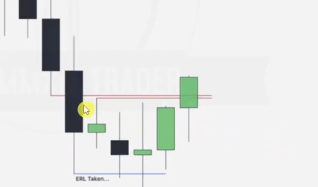

Going to the 4hr chart

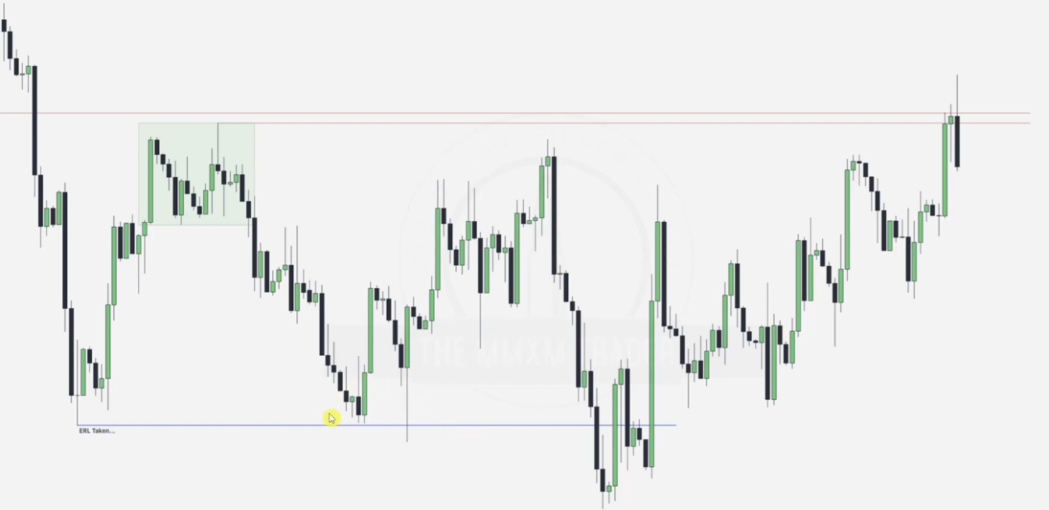

We note the original consolidation, checking the point where ERL is taken out, we note the order pairing, after which to complete market reversal, the break in market structure causes a 4Hr FVG

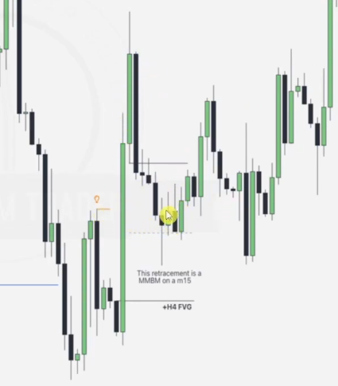

Note that retracement into this 4Hr FVG forms a potential MMBM on a 15 min chart

Going to the 15 min chart, we draw out our original consolidation and the 2 accumulation points.

Note that the original consolidation forms the highest buy stops being hunted.

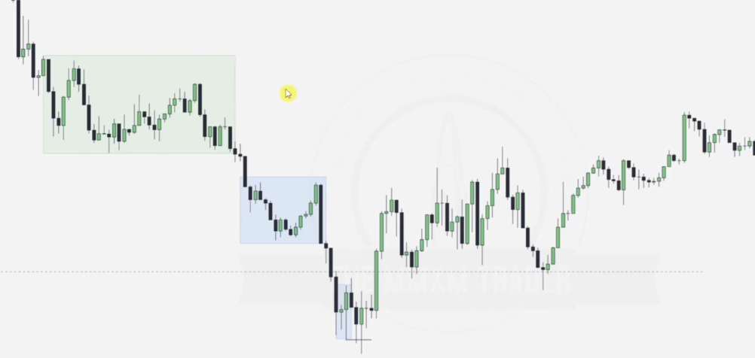

Since our retracement into the 4hr FVG causes the 15 min MMBM, , note that when the ERL marked is taken out, order pairing, we have a 15 min FVG formed as a break of structure

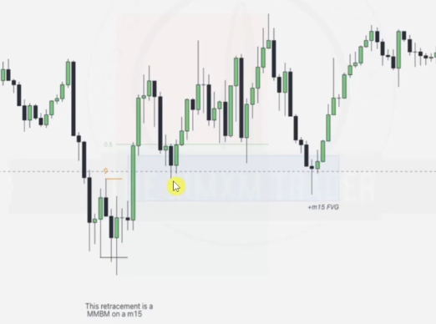

We draw our prem_disc and note that the FVG formed is in discount, note that first tap into the FVG as indicated by the cursor is taken out in second tap -- in all these instances FVG is still not taken up hence can be tapped into as ERL - IRL reference.

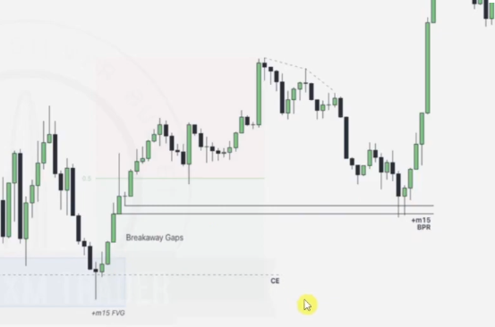

After the second tap, we monitor formation of a disount BPR as above

Lets go into the sessions timing for entries

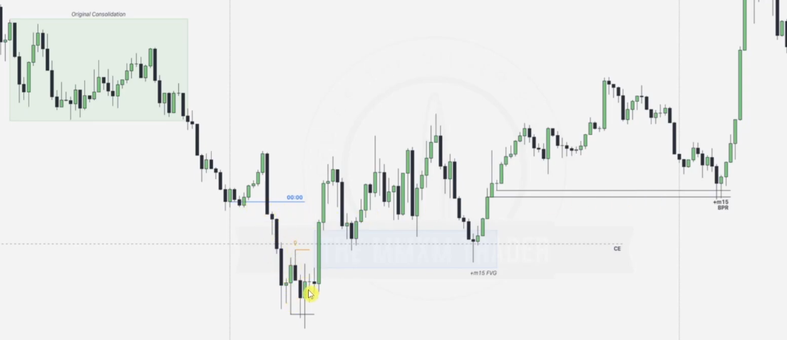

Original consolidation sets the buy stop.

On Monday we draw our midnight open and note that low of the day is formed in the london session.

After low of the day is formed , we expect a break in structure and we note that the first 15 min FVG is formed, this is one of the first points of entry.

Second opportunity arrives on Tuesday where privce taps into the BPR in discount and we expect it to hunt for the buy stops set up by the original consolidation

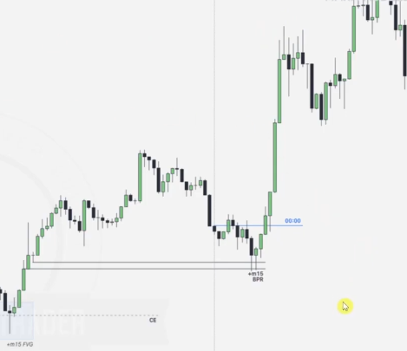

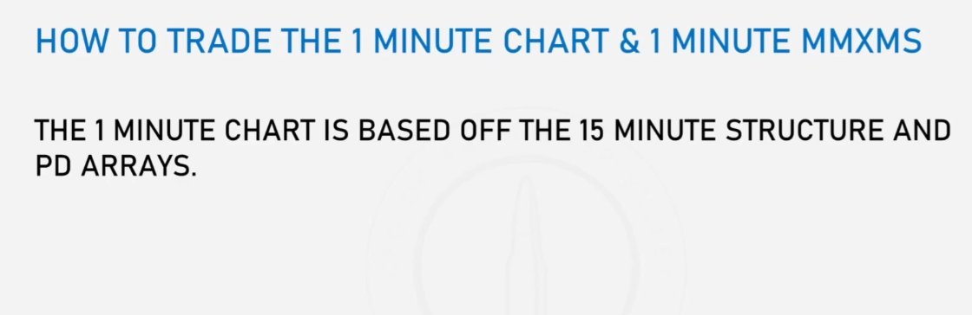

From our original 15 minute chart, we note that we can form a 1 minutes MMBM using the **From here to here**

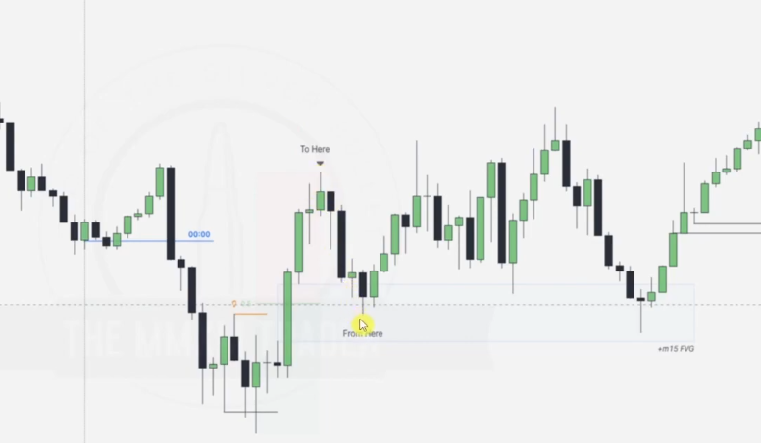

Draw the MMBM buy stop as illustrated

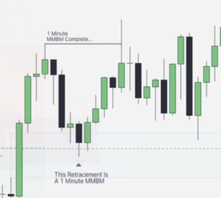

Going to the 1 min chart

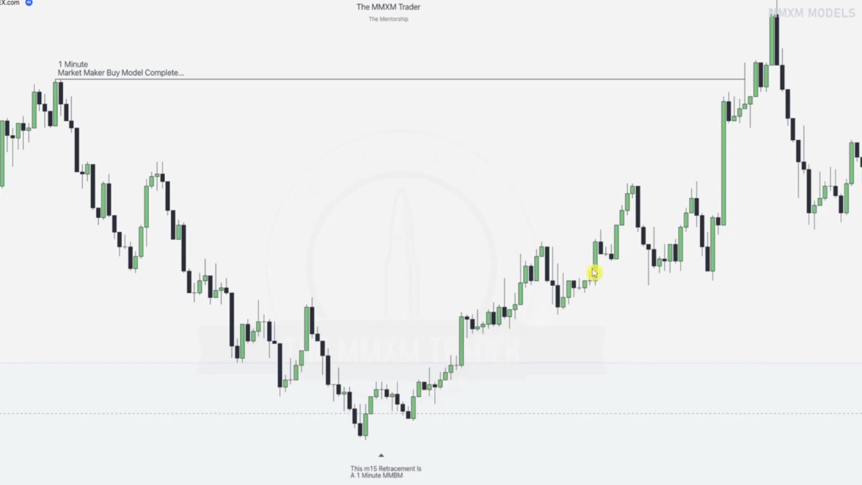

Note the consolidations and accumulations

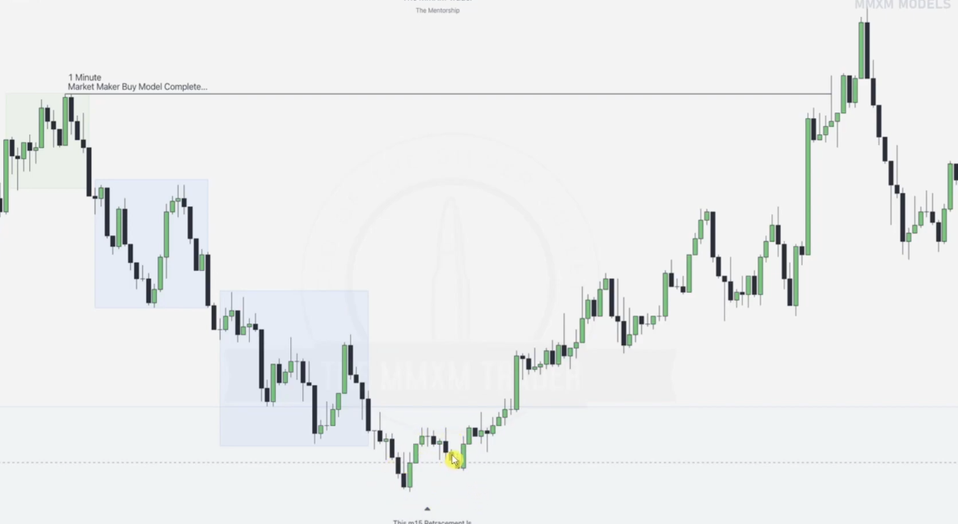

Note that order pairing only happens when price taps into arrays / ERLs of higher time frames?? as said and from this one the first tap is not an order pairing because it didnt hit the CE of the FVG??

In Forex trading, the **CE (Consequent Encroachment)** of a **Fair Value Gap (FVG)** refers to the midpoint or 50% level of the gap.

A **Fair Value Gap** is an imbalance between buyers and sellers, often identified when a large price movement occurs with minimal or no opposing orders filling the gap. It is typically found in strong trending markets, visible on candlestick charts as three consecutive candles where the second (middle) candle has a large body, and the first and third candles do not fully overlap it.

### ****How to Calculate CE of an FVG:****

The CE of an FVG is calculated as:

CE=High of FVG+Low of FVG2\text{CE} = \frac{\text{High of FVG} + \text{Low of FVG}}{2}CE=2High of FVG+Low of FVG​

Where:

* **High of FVG** = The highest price of the imbalance.
* **Low of FVG** = The lowest price of the imbalance.

### ****Why is CE Important?****

1. **Key Reaction Level:** Prices often revisit the CE level before continuing in the original trend.
2. **Confirmation for Entries:** Traders use it to confirm entries or take partial profits.
3. **Support or Resistance:** It acts as a dynamic support/resistance level within the gap.

### ****Example:****

If an FVG is identified between 1.2000 (high) and 1.1950 (low), the CE level would be:

1.2000+1.19502=1.1975\frac{1.2000 + 1.1950}{2} = 1.197521.2000+1.1950​=1.1975

This 1.1975 level may act as a point of interest for potential price reactions.

Let me know if you'd like further clarification!

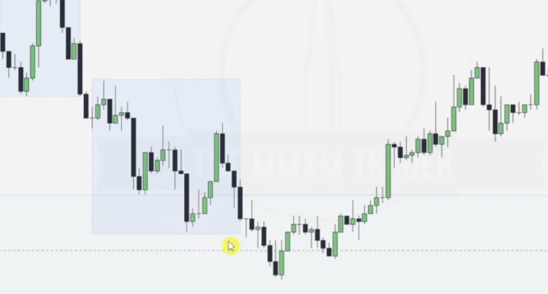

Note down the market structure shift formed by this order block

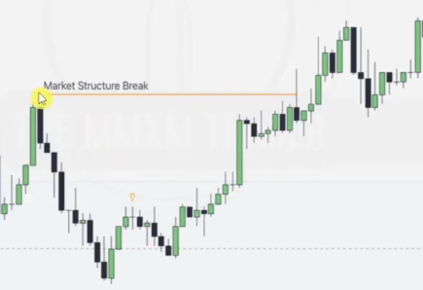

When this order block is taken over to form a breaker block it forms a key level for a new order block as aligned

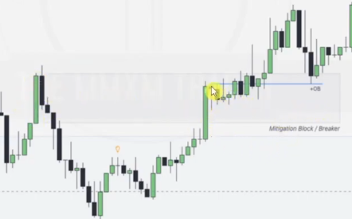

This new OB provides support for price to go higher

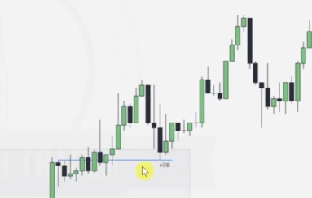

Note that new mitigation block here will form key level for this FVG, all in all we are hunting for the buy stop formed by the original consolidation

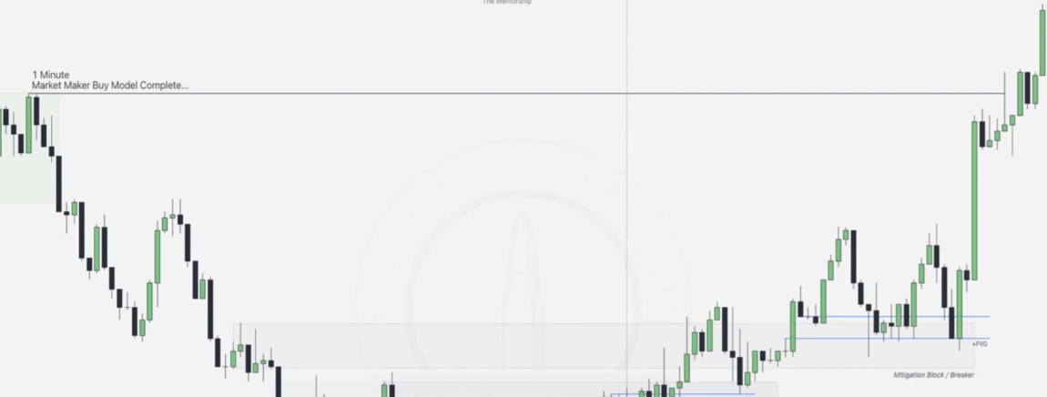

Also note that we need to take our opportunities in the right kill zones, note that here the order pairing happened in before the NY killzone, after that we can take on our opportunities in the NY kill zone

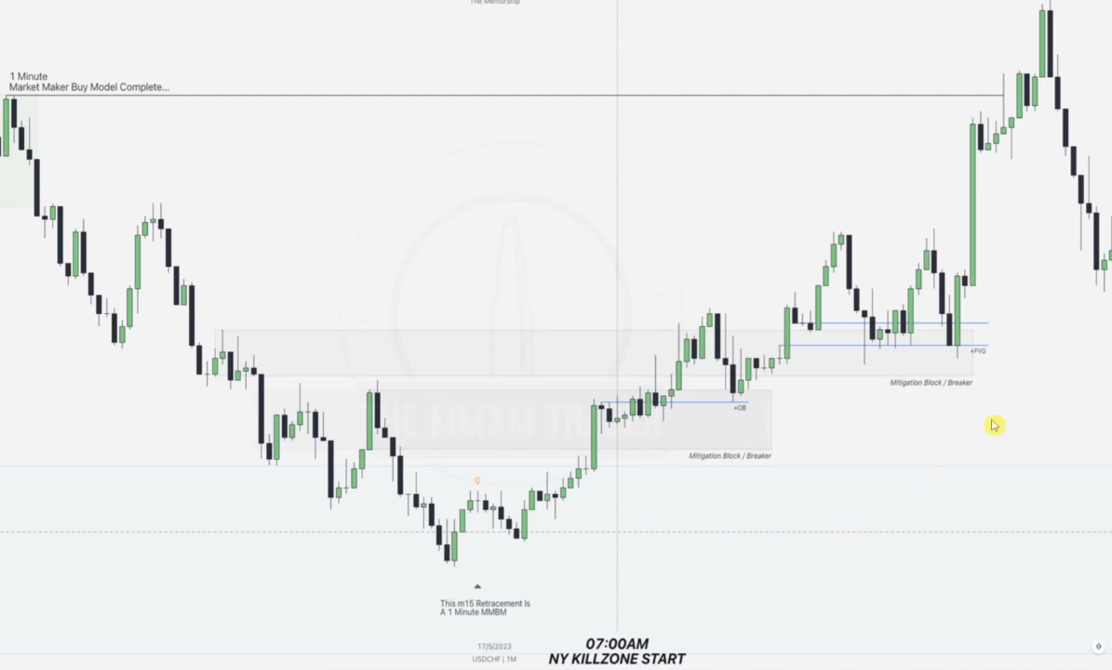

EXAMPLE

Given a monthly chart

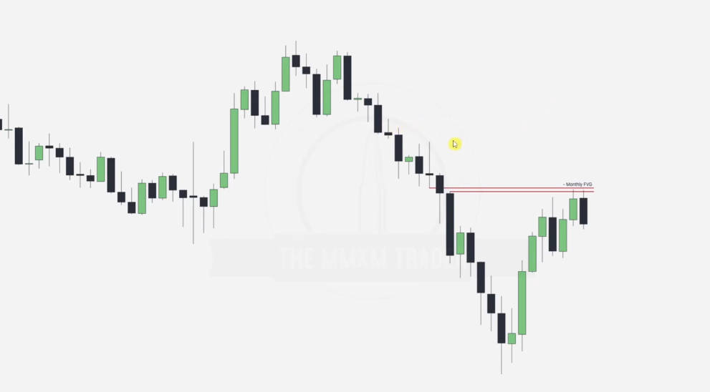

After noting our monthly FVG , remember from time frame alignment, next step is now daily chart at the point where we touch the monthly FVG

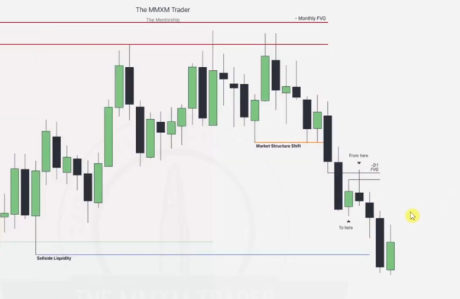Note the SSL being taken out and the market structure shift, from this .

Note the daily FVG formed and the ERL > IRL taking of the Daily SSL, from here we can forge a 1 hr MMSM as below

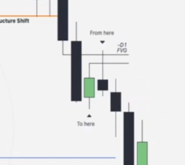from here to here

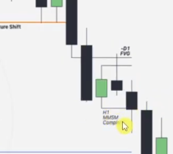

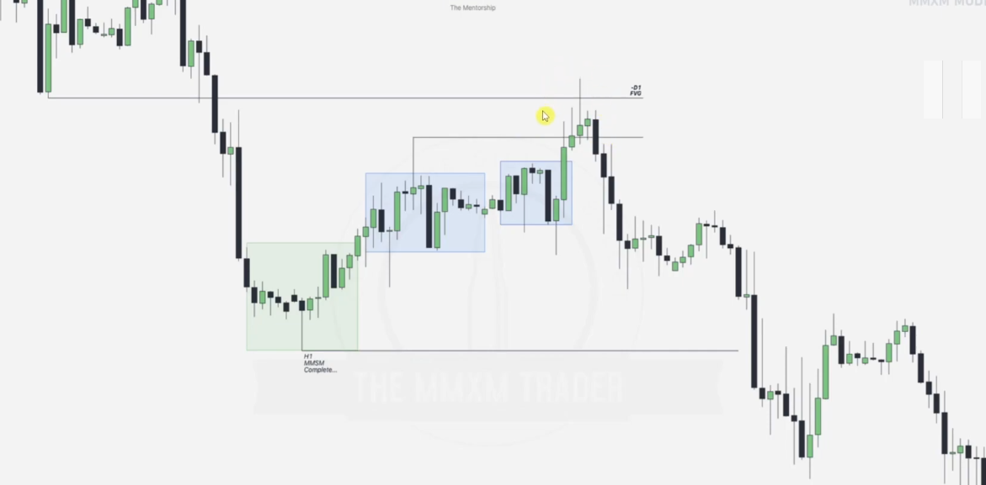

1 hr chart, note the original consolidation-- forming low of the day and the accumulations.

We start anticipating hunting for the SSL created by the original consolidation once we hit the daily FVG, question is FROM WHERE

Note this breaker block

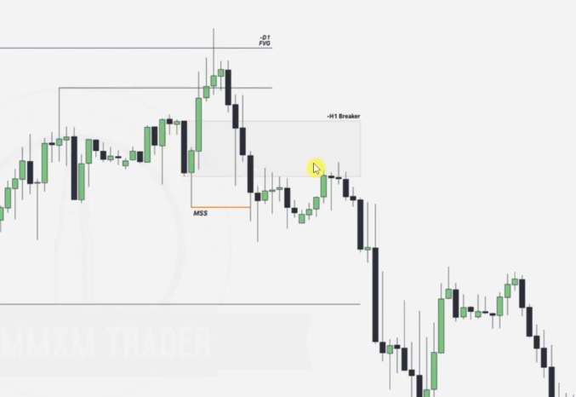

Note the bearish OBs at the beginning of both the bearish displacements

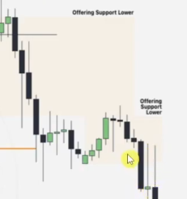All of them offering support lower.

Now to go to the 5 minute timeframe to enter the market, note

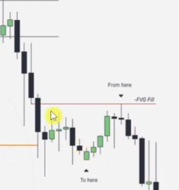from here to here we see a MMSM

Note that we use the FVG fill as the Premium array, this is an FVG that has been almost filled

Anticipating an **FVG (Fair Value Gap) fill** to signal either a **reversal** or **continuation** depends on several key factors, including market structure, order flow, and confluence with other technical elements. Here’s how you can determine whether an FVG fill might indicate a reversal or continuation:

### ****1. When an FVG Fill Signals a Reversal:****

You should anticipate a reversal after an FVG fill if the following conditions are met:

#### ****A. Key Support/Resistance Levels****

* The FVG aligns with a **significant support/resistance zone** (e.g., previous swing highs/lows, order blocks).
* If price reaches the FVG and reacts sharply at a historically respected level, it suggests a reversal.

#### ****B. Overextended Market Conditions****

* If the price has been trending strongly and shows signs of exhaustion (e.g., RSI divergence, declining volume).
* A sharp rejection after the FVG fill signals potential trend exhaustion and reversal.

#### ****C. Liquidity Grab & Smart Money Concepts (SMC)****

* If the price aggressively sweeps liquidity above/below key levels (e.g., taking out stop losses), then reverses after filling the gap.
* Look for **stop hunts**, where price briefly fills the FVG and reverses immediately.

#### ****D. Change in Market Structure (CHoCH/BOS)****

* A **Break of Structure (BOS)** or **Change of Character (CHoCH)** in the opposite direction after the FVG fill confirms reversal intent.
* For example, if the price fills a bullish FVG but then creates lower lows, a bearish reversal is likely.

#### ****E. Rejection Candlestick Patterns****

* Presence of bearish/bullish reversal candlestick formations (e.g., engulfing patterns, pin bars, doji) at the FVG fill zone.

NOTE THAT OUR FILL OCCURS AT A POINT WHERE BREAKER BLOCK IS BEING RETESTED HENCE REVERSAL

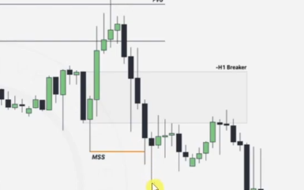

### ****2. When an FVG Fill Signals Continuation:****

You should anticipate continuation if the following conditions apply:

#### ****A. Trend Confirmation****

* The overall market structure remains intact (e.g., higher highs in an uptrend, lower lows in a downtrend).
* The FVG fill acts as a **trend continuation pullback**, with price resuming in the original trend direction.

#### ****B. Order Flow and Volume Increase****

* Increased volume and momentum after the FVG fill indicate market participants are supporting the trend.
* A weak rejection or shallow retracement suggests continuation.

#### ****C. Confluence with Other Technical Levels****

* If the FVG fill aligns with trendline support/resistance, Fibonacci retracements (e.g., 38.2% or 50% levels), or moving averages (e.g., 50 EMA).
* A bounce from the FVG with additional confirmation suggests trend continuation.

#### ****D. Formation of Higher Lows/Lower Highs****

* In an uptrend, if price fills a bullish FVG and forms a higher low, expect continuation.
* In a downtrend, price filling a bearish FVG and forming a lower high signals continuation.

#### ****E. Institutional Order Blocks****

* If an FVG fill coincides with an order block, price may consolidate briefly before continuing in the same direction.

**Example:**  
If price fills a bullish FVG, aligns with a 50 EMA support, and prints a higher low, the trend is likely to continue upward.

### ****How to Approach FVG Fill in Trading:****

1. **Wait for Confirmation:** Use candlestick patterns, structure breaks, or indicators (RSI, MACD) to confirm the expected reaction.
2. **Monitor the CE (Consequent Encroachment):** A strong reaction at the 50% FVG level often indicates trend continuation.
3. **Set Alerts:** If price approaches an FVG zone, be prepared to react based on confirmation signals.
4. **Use Risk Management:** Always place stop-losses below/above the FVG zone based on structure.

NOTE: The reason why where are going MMSM all the way is bcoz we noted that the day was bearish from the beginning

5 min chart

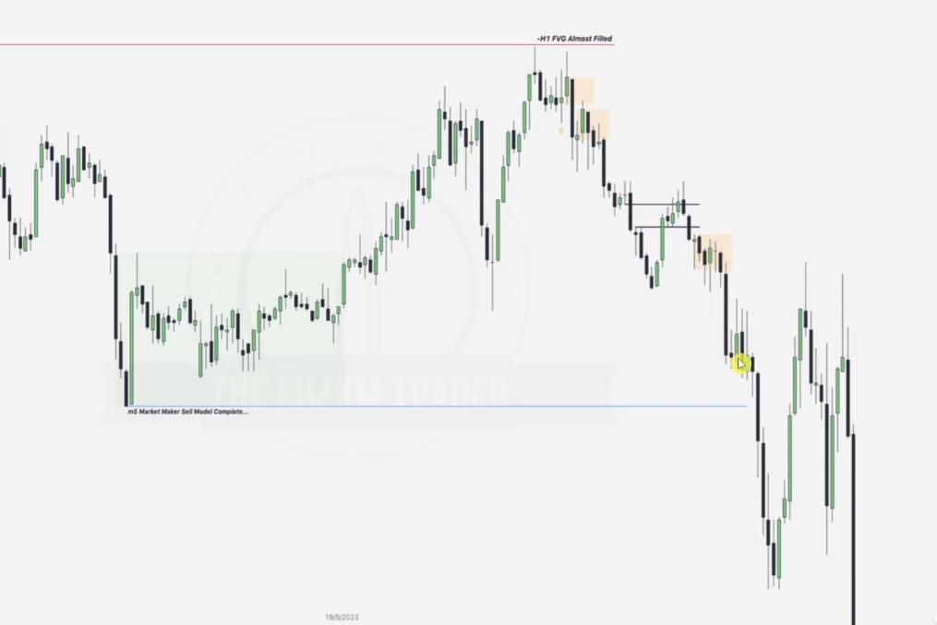

Note original consolidation forming the low, the failure swings, ERLs Vs IRLs and the up close OB candles and the FVGs supporting price to go lower

THE SILVER BULLET

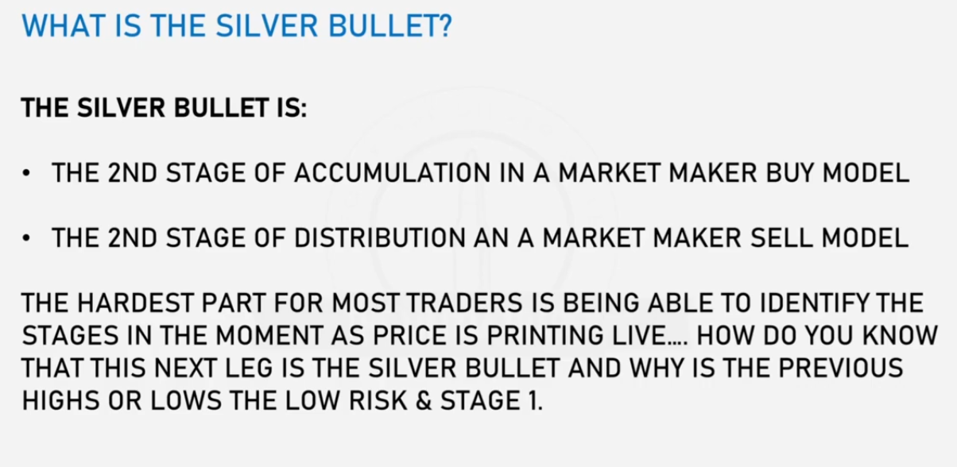

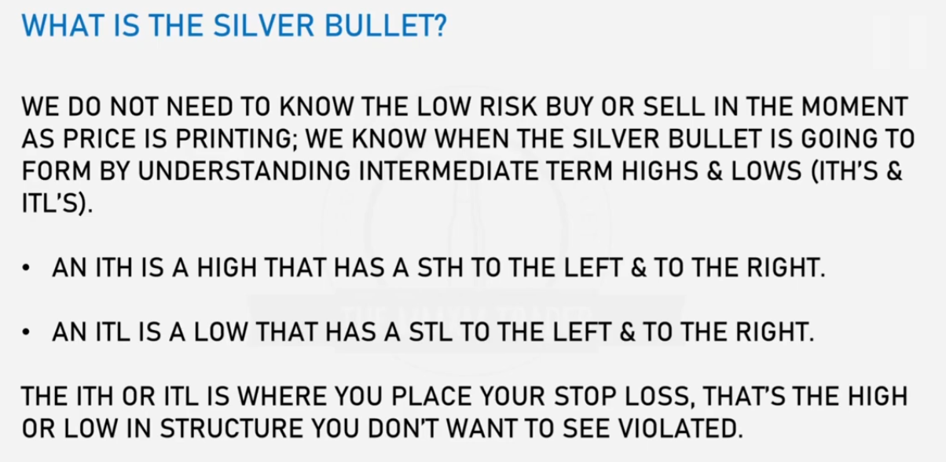

STH/L-- Short Term High/ Lows

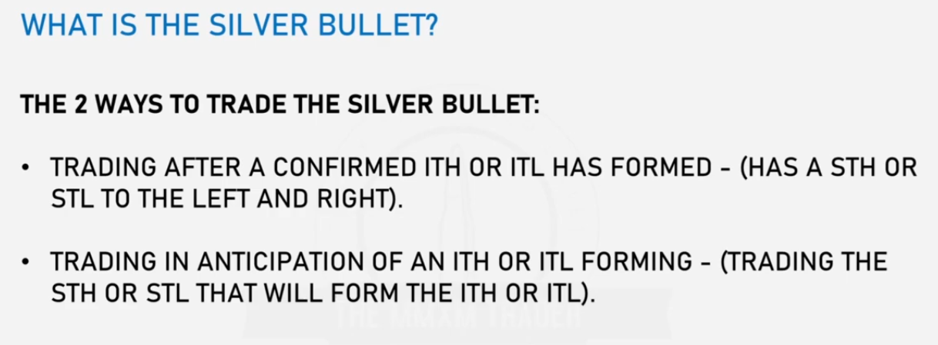

Given a MMBM

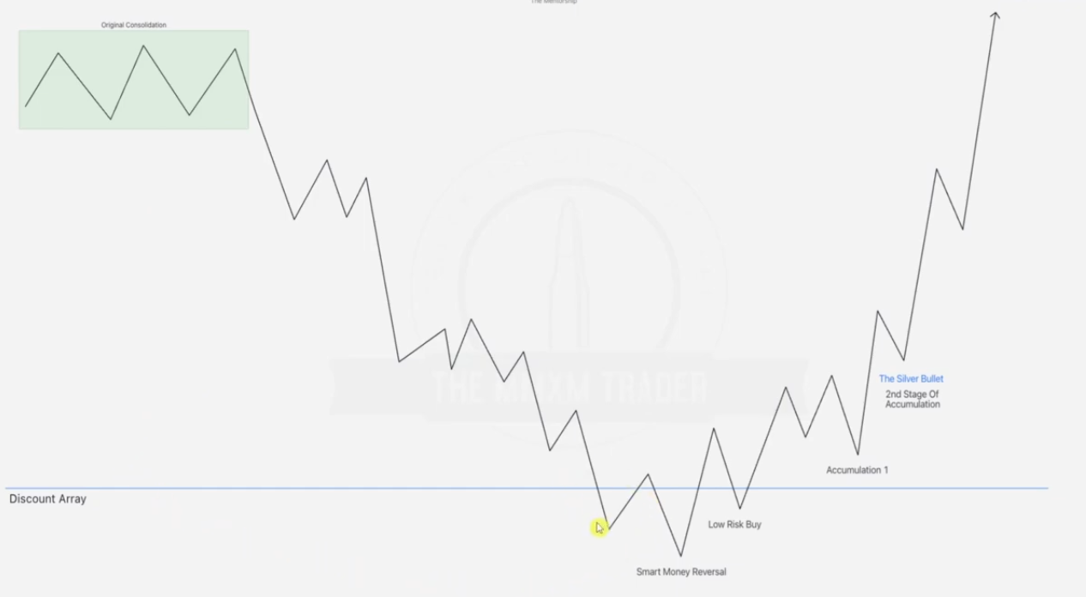

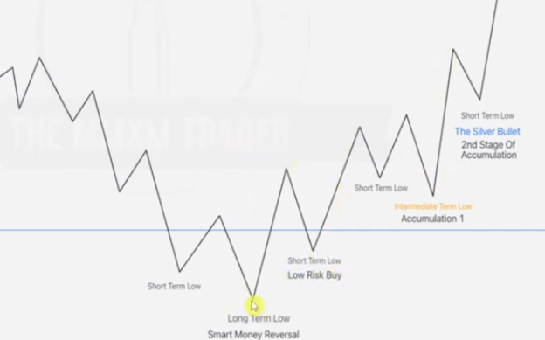

Long term low... this is the extreme low in this range and has short term lows to the left and right of it.

There will be various short term lows, but we will wait for the short term low after the low risk buy then the next raid is our intermediate term low ITL, we expect price now not to raid the ITL

The second short term low forming after the ITL is the silver bullet and is the point defining the entry called silver bullet.

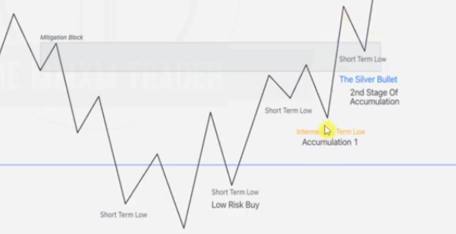

You can use the mitigation block and various ideas to determine the probability of where the silver bullet short term low will be formed. FOR NOW LETS FOCUS ON USING MITIGATION BLOCKS

Second MMBM Model

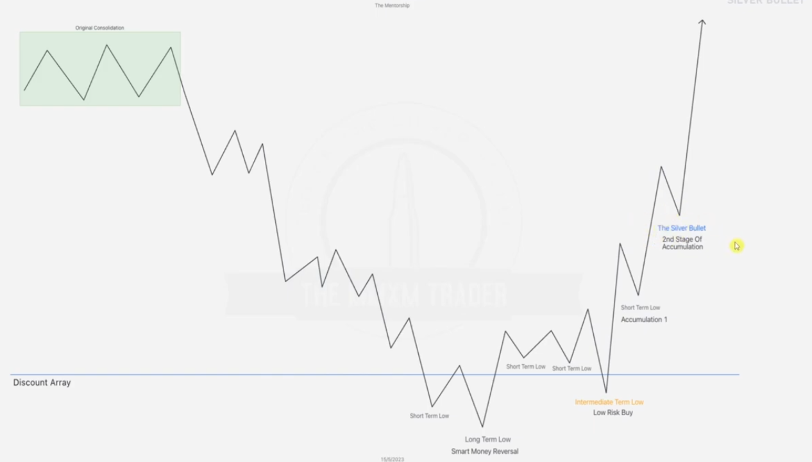

Here instead of immediately forming a low risk buy after the long term low, equal highs draw themselves out and short terms lows formed draw themselves out too, after that we form the low risk buy which is now the ITL. The 1st STL to to the right of the ITL is the 1st accumulation, silver bullet forms in the 2nd stage of accumulation.. i.e STL to the right of the 1st accumulation.

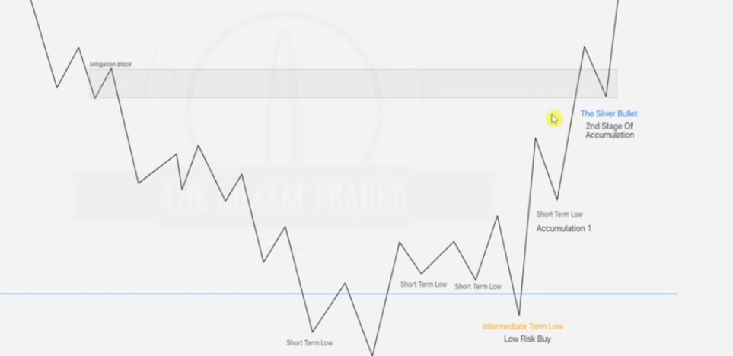

We can still use the mitigation blocks to determine the silver bullet entry from here too

Given a MMSM

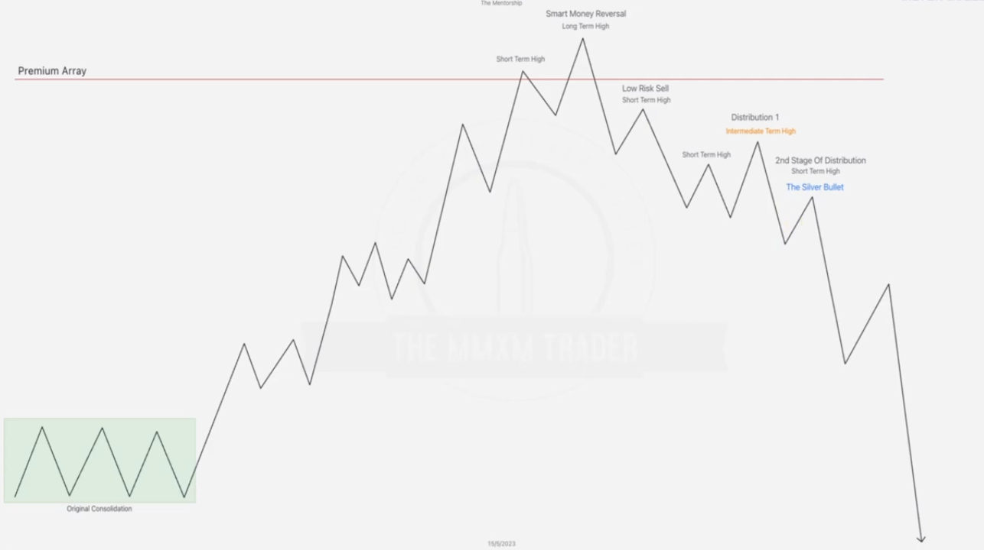

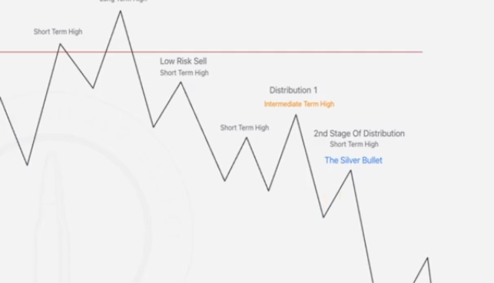

Note the Low risk sell formed after reversal as a STH and the next STH sits on the left of the ITL to which the

**Second scenario**

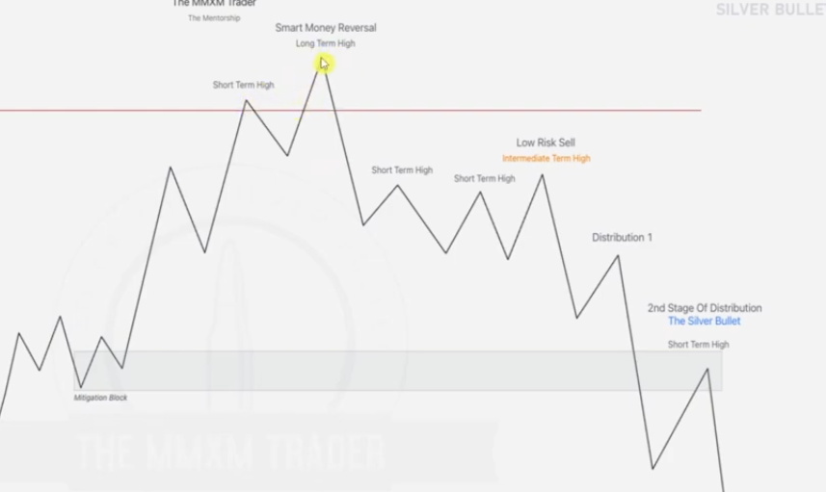

Drawing mitigation block in the first scenario

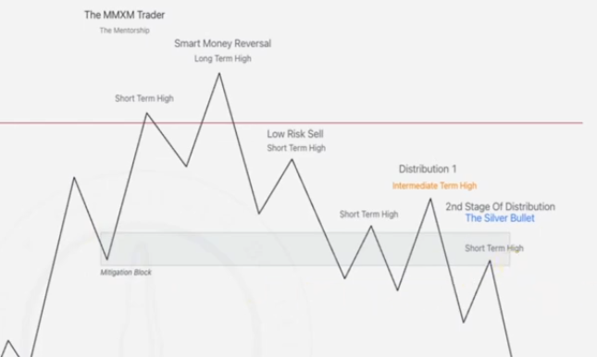

STH forming in the mitigation block causes the high prob silver bullet setup

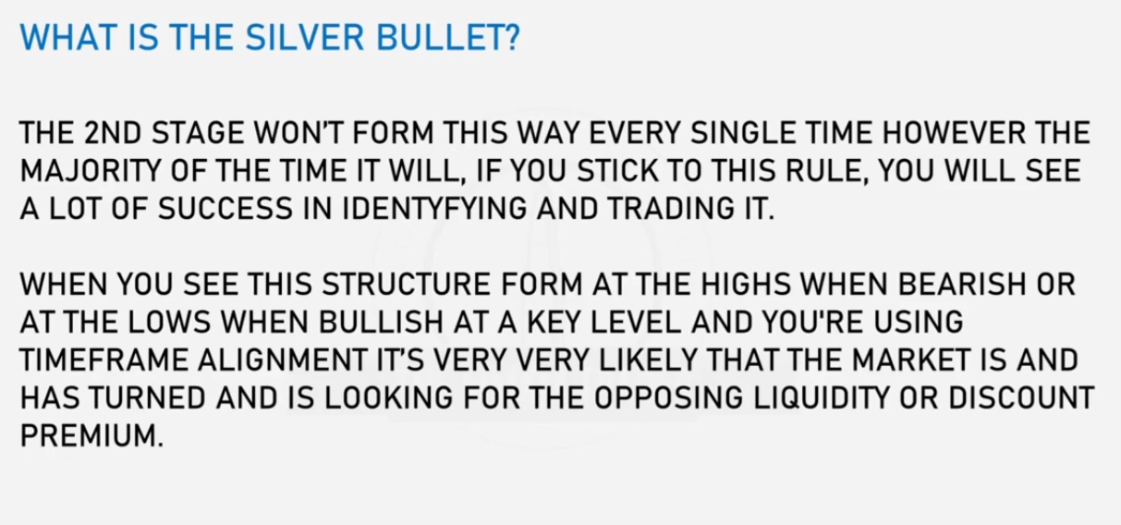

EXAMPLE ONE

Given daily chart

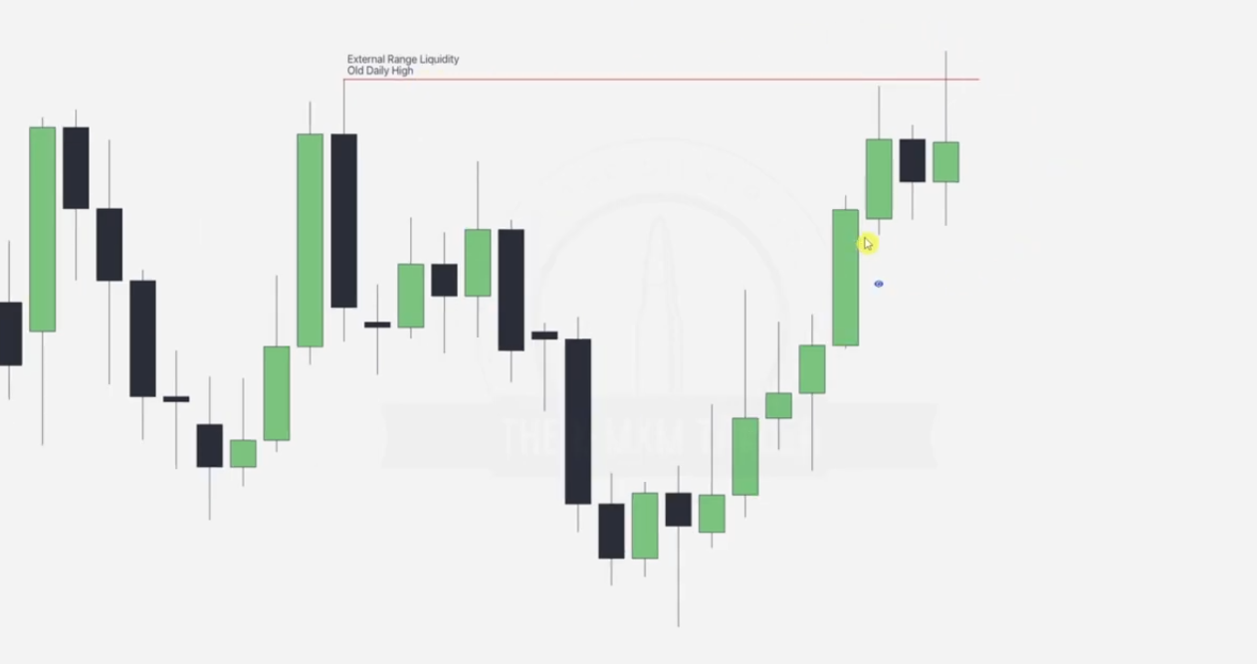

Our next draw after taking out the old high or low is this FVG formed in the process(ERL_IRL)

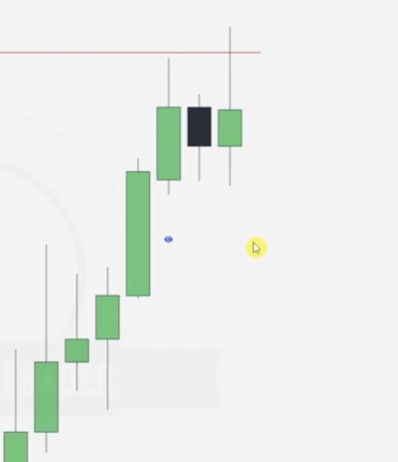

Which is taken out as seen

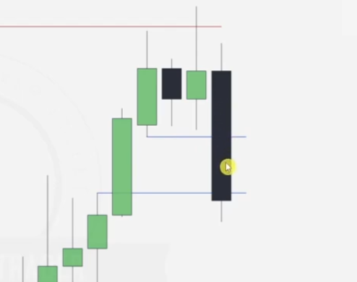

Going to the hourly chart

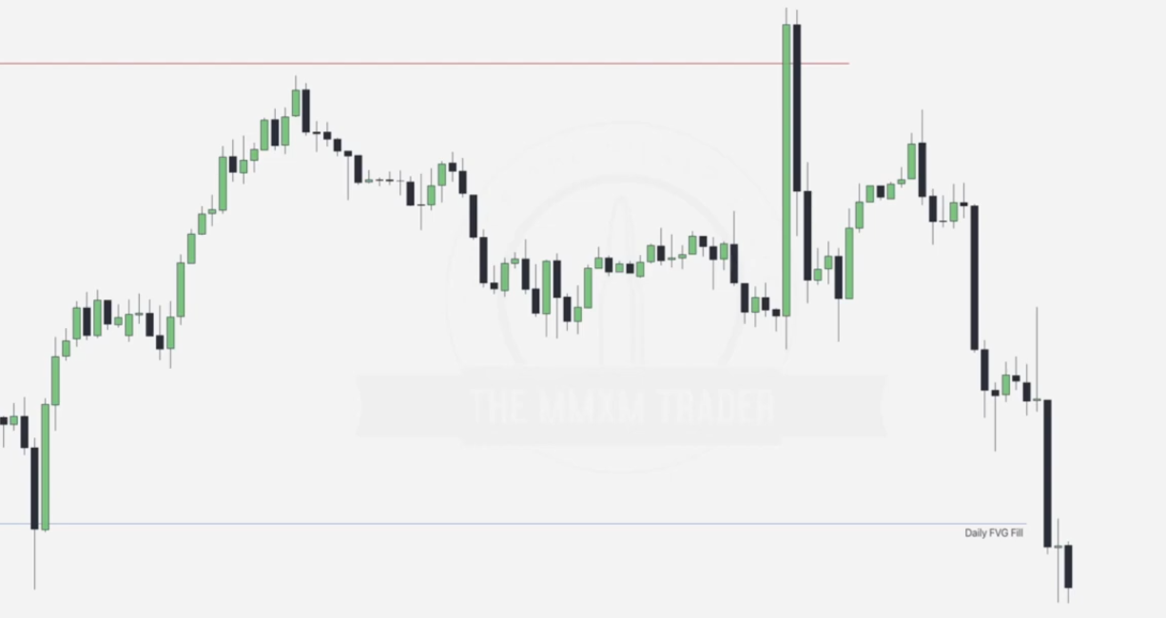

Next task is identifying where the ITH will fall

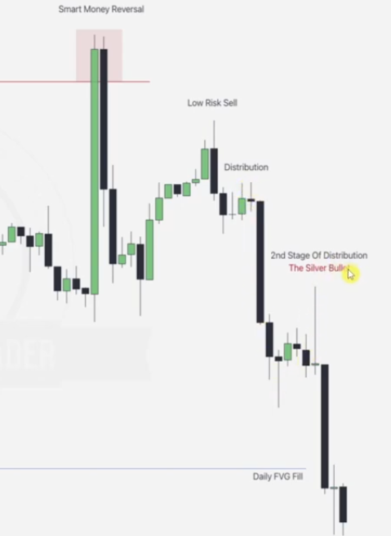

Silver bullet is always the second stage of distribution, note that when we are drawing out the up down curves, we base on price swings(where is is kinda change in original direction and the candle combination of 3 contain bullish and bearish all).. i.e highest point before price goes down--bearish in this case, this gives us out Low Risk sell.. STH of the Peak reversal, 1st distribution and then 2nd distribution. The silver bullet is always located in the second distribution.. price re-going down. The final draw in this case is the Daily FVG.

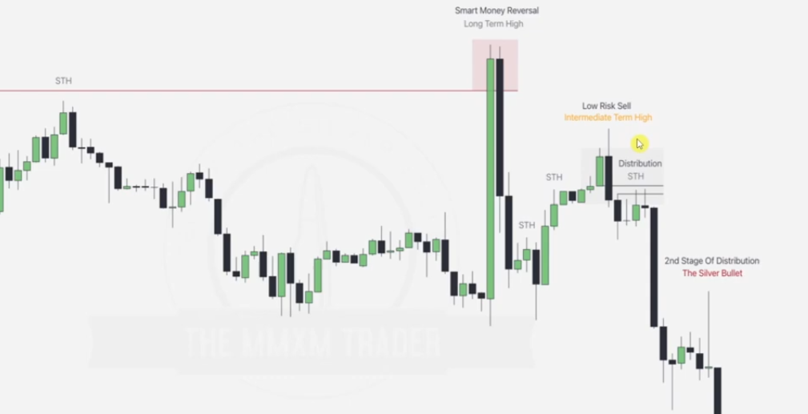

Note that the STH swings are drawn at every bullish-bearish block combo, taking the highest of them in the swing(3 candle formation).

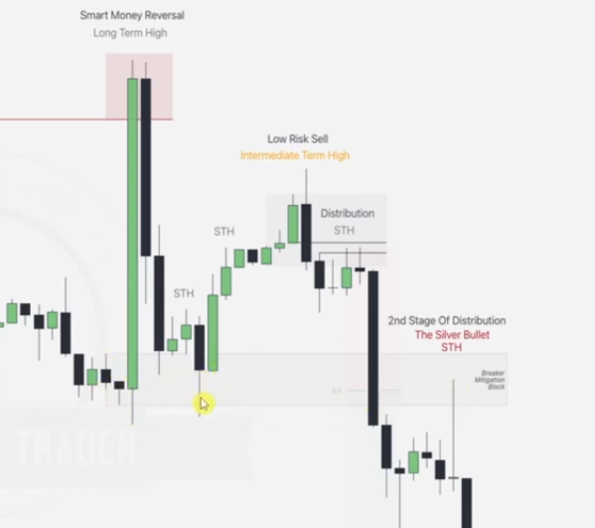

To check whether this silver bullet is high probability, we note out the breaker/ mitigation block as above and also keenly note the wick of the order block overlapping with the breaker/mitigation block as shown by cursor.

EXAMPLE 2

Given 30 minute futures chart

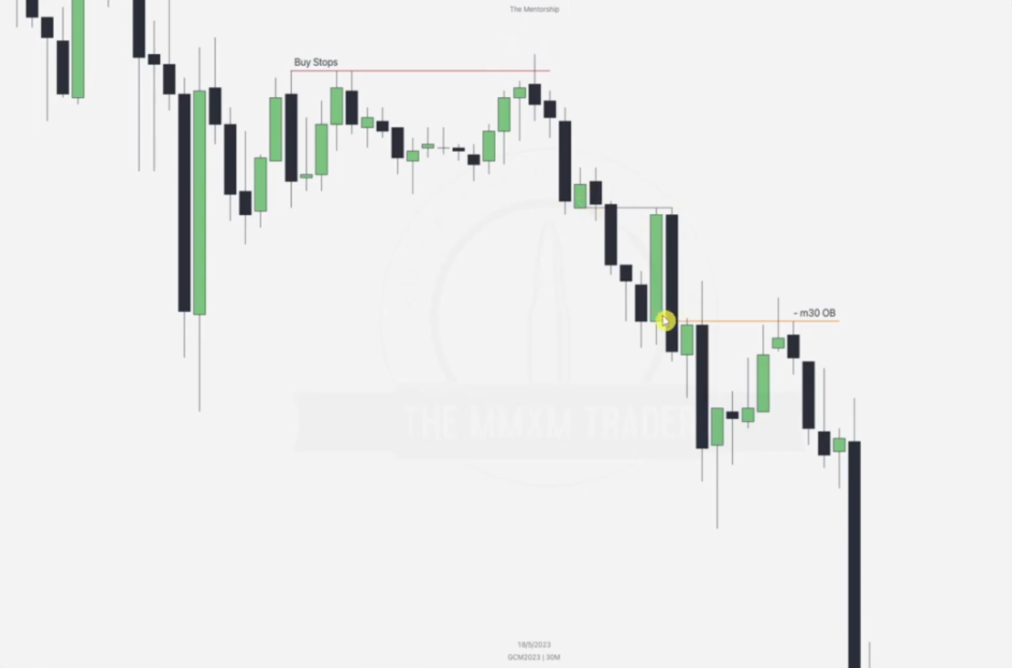

Respect the ERL_IRL(ERL swing highs and lows are formed at bearish--bullish candle formations-- 3 candles depending on which is higher and the bias), Failure swings to engineer liquidity, breaker and order blocks formed.

Going to the 3 minute time frame to see if we can spot the silver bullet setup

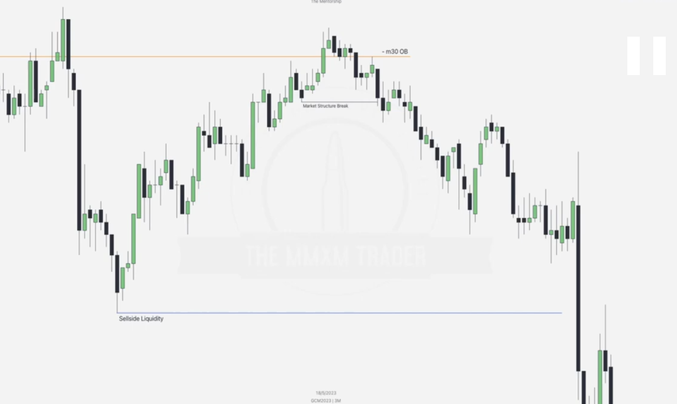

Spotting the STHs , ITH and silver bullet

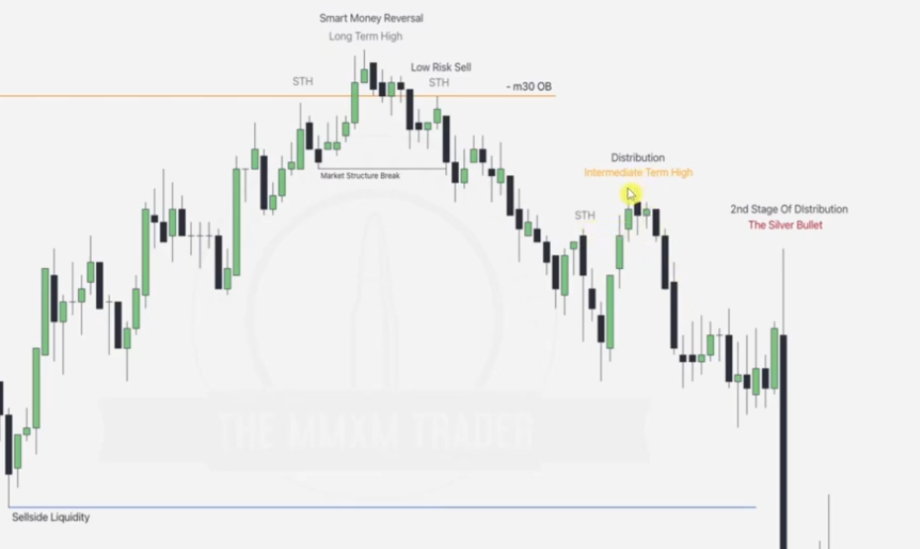

REMEMBER: When spotting STH, we spot failure swings... bearish-bullish 3 candle formation trying to change direction by trying to take on minor ERLs in the bias but fails... swing -- go up -- come down

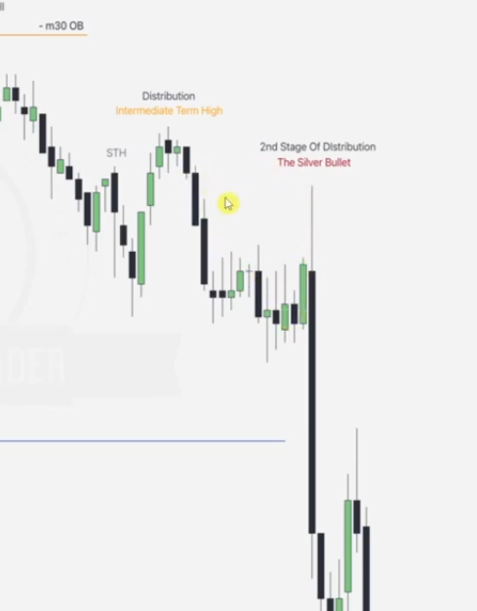

Stop losses can be placed just at the ITL , but before we enter the market from here it is advisable to wait for the FVG formed in the process to be hit

Also note the mitigation block as below -- not breaker this time

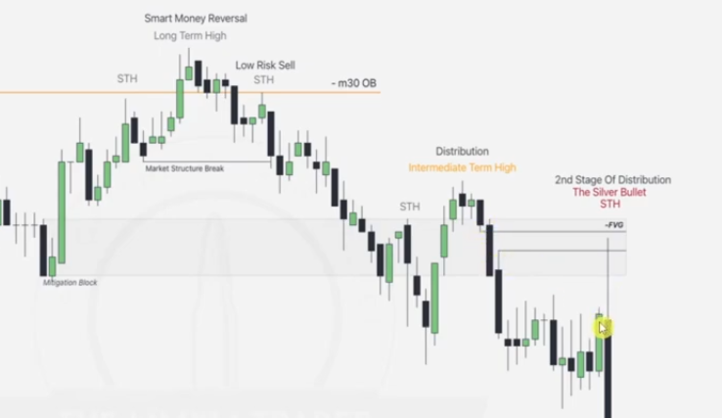

EXAMPLE

Given a 4hr chart

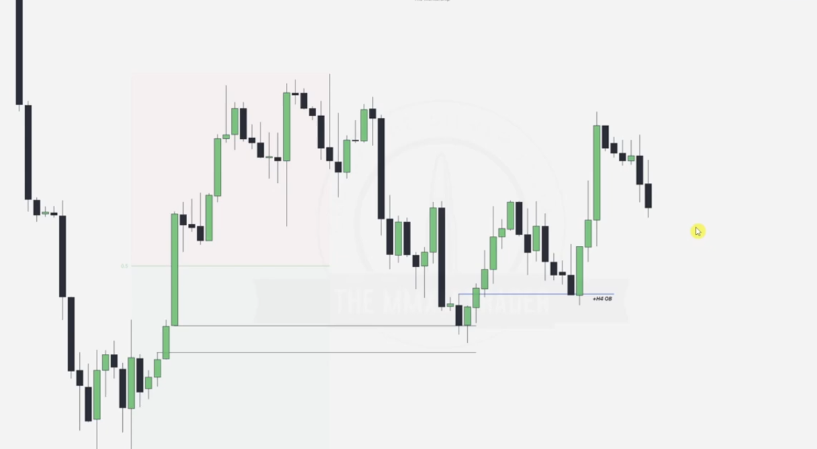

We draw the OB to act as the discount array for our MMBM in next timeline

Going to 15 minute chart

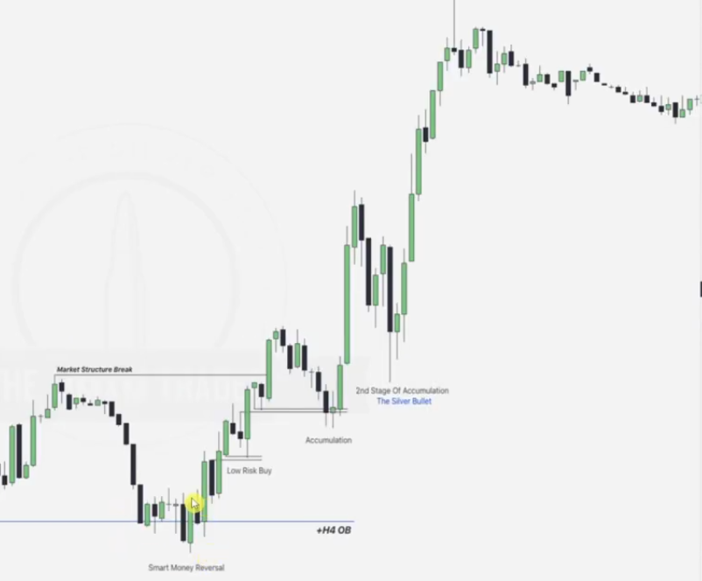

Marking out the STLs , ITLs

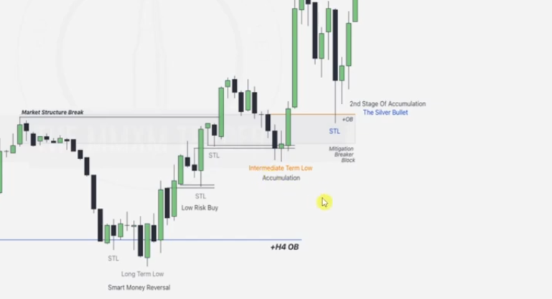

Note the mitigation block too

Given 30 minute chart, note the BPR array to act as the discount array

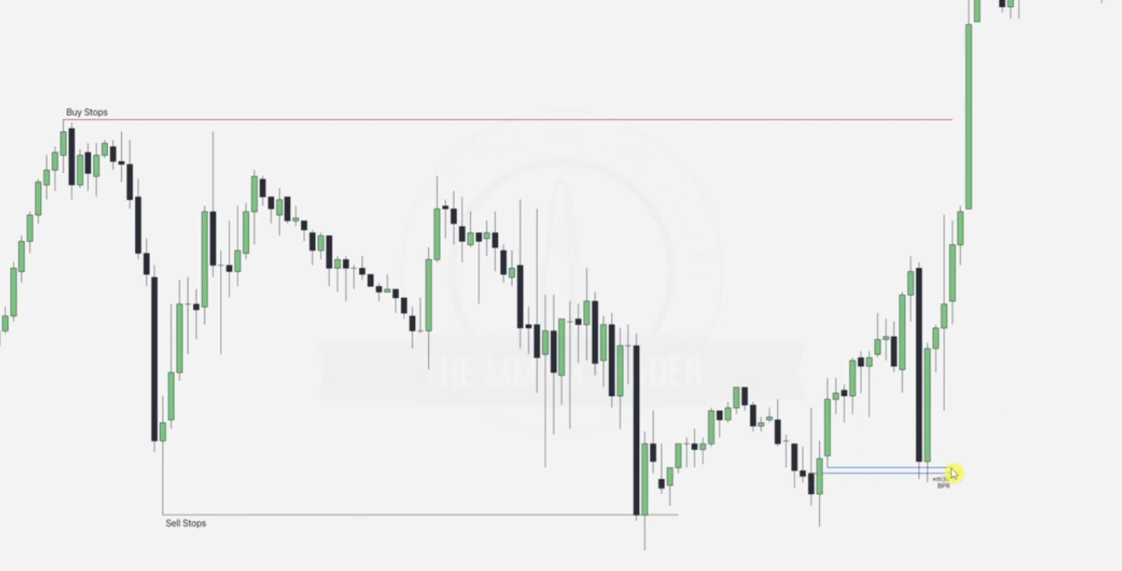

Going to 3 minute

